<https://plnkr.co/edit/wH1f1c8LMV8Vvi8yuslA?p=preview>

Plnkr.co

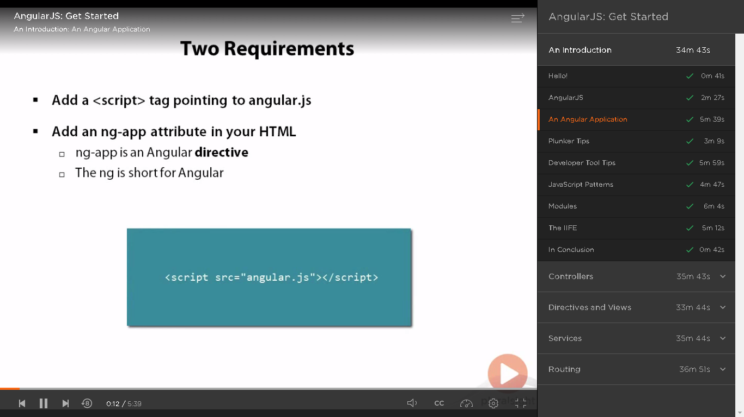

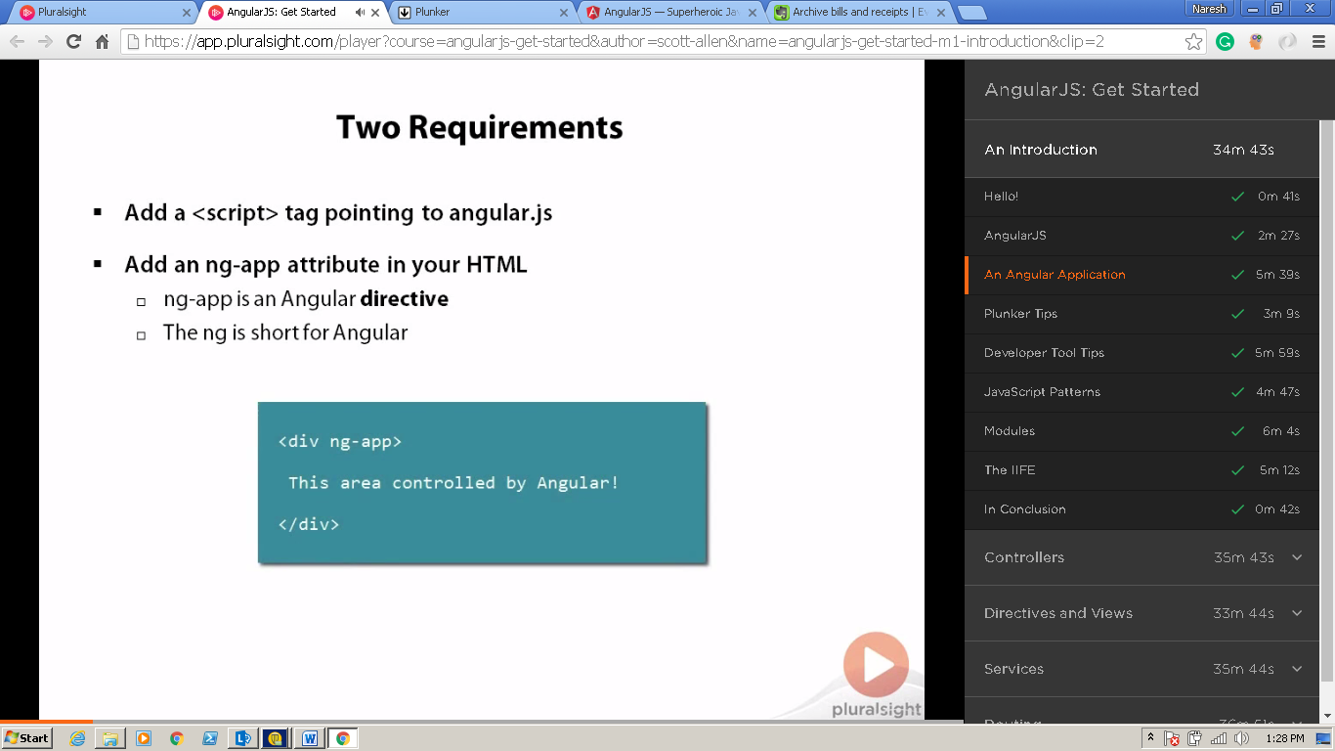

**ng-app**

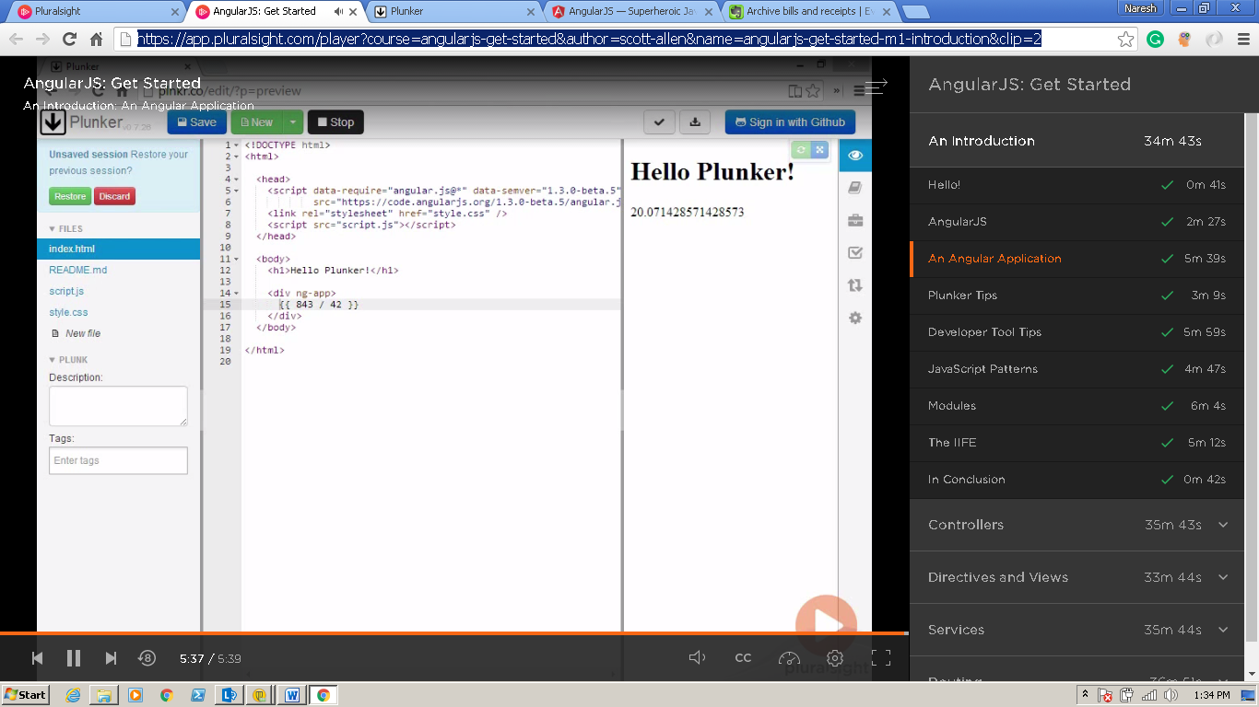

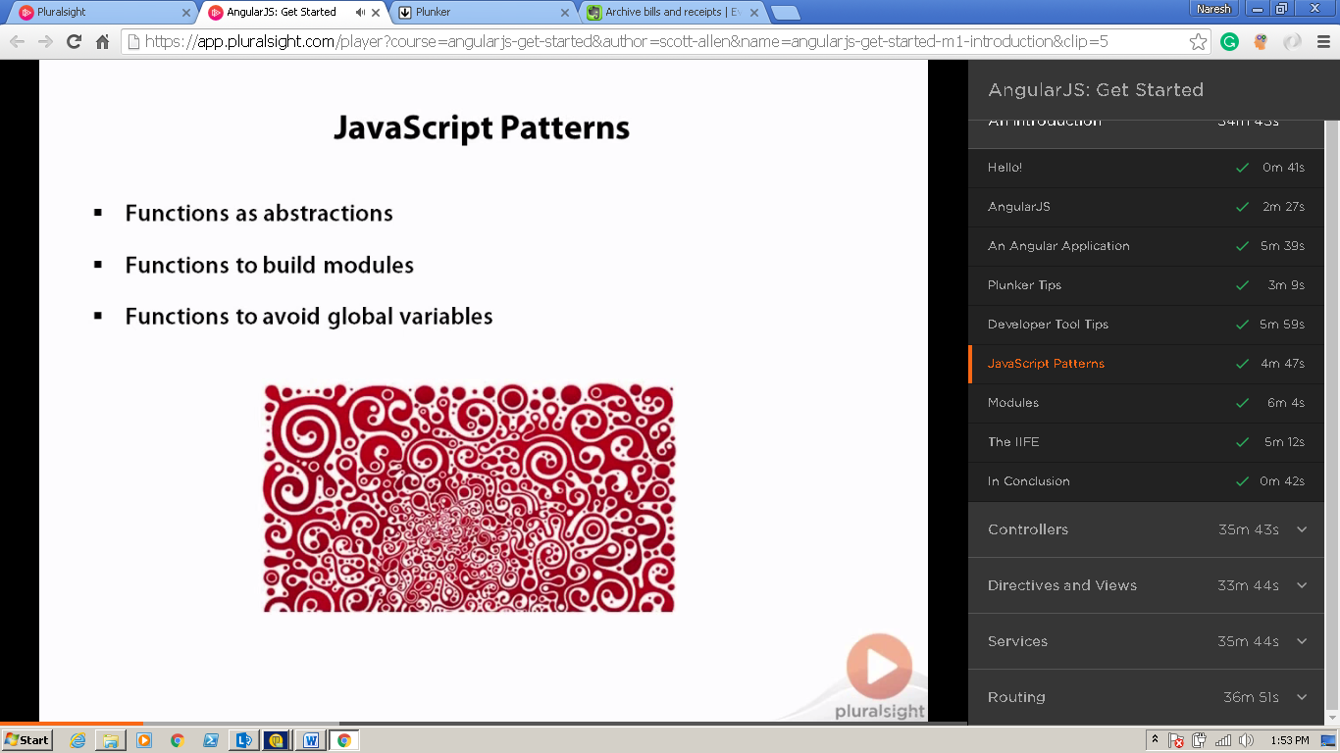

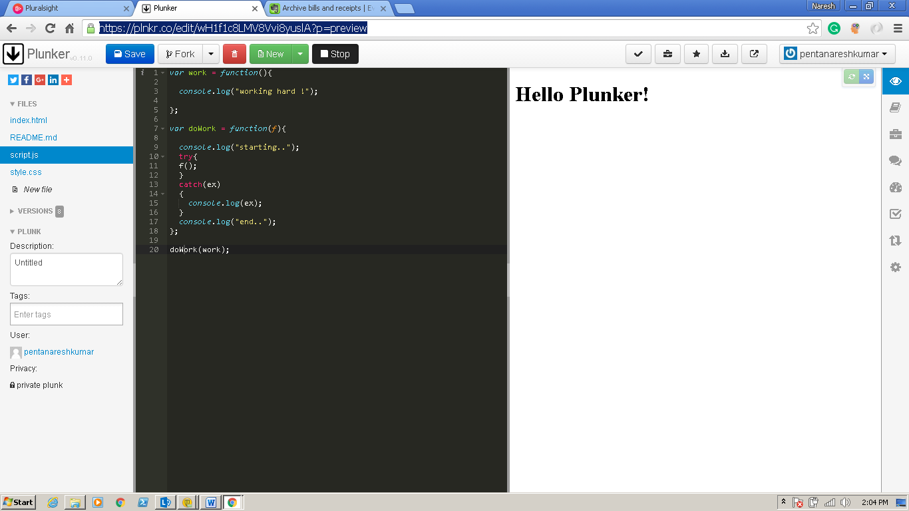

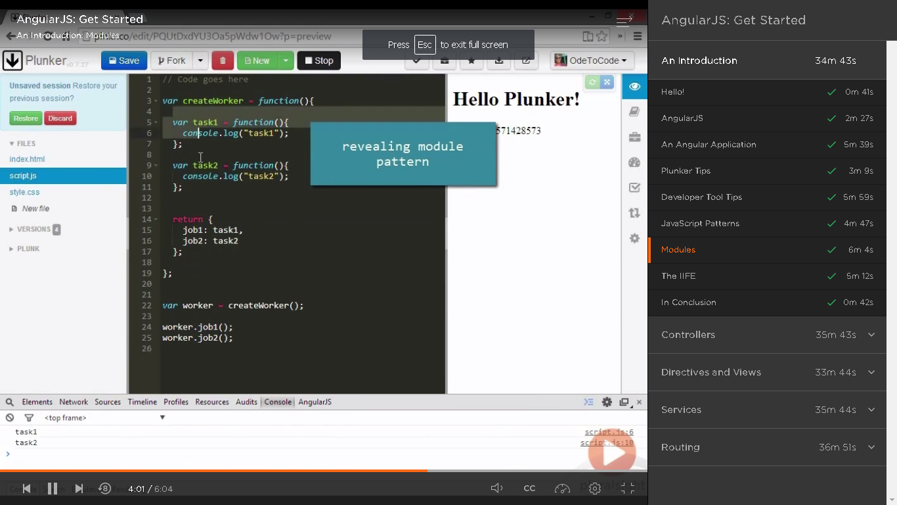

Without Global Variable – revealing module pattern

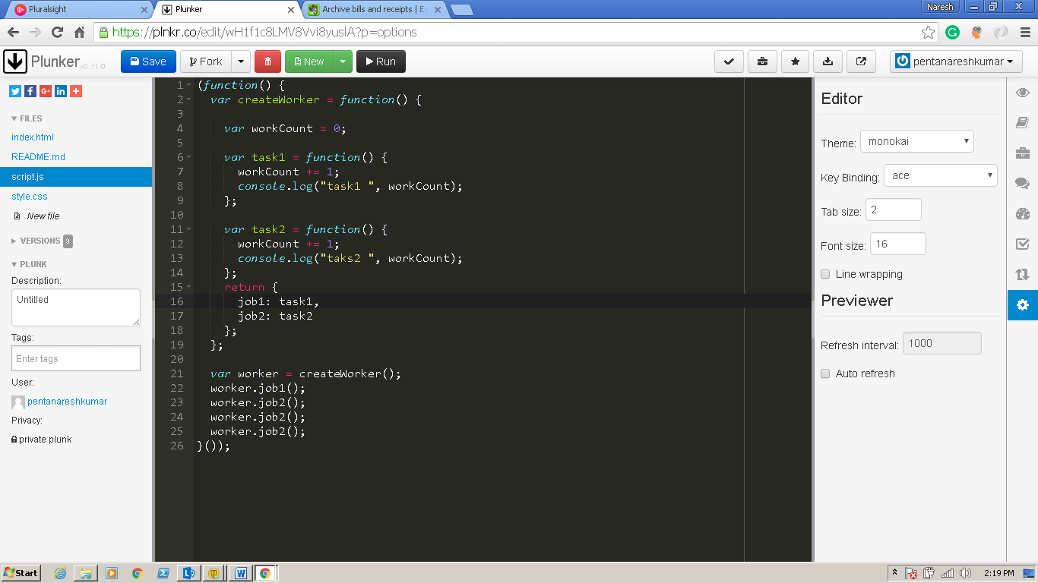

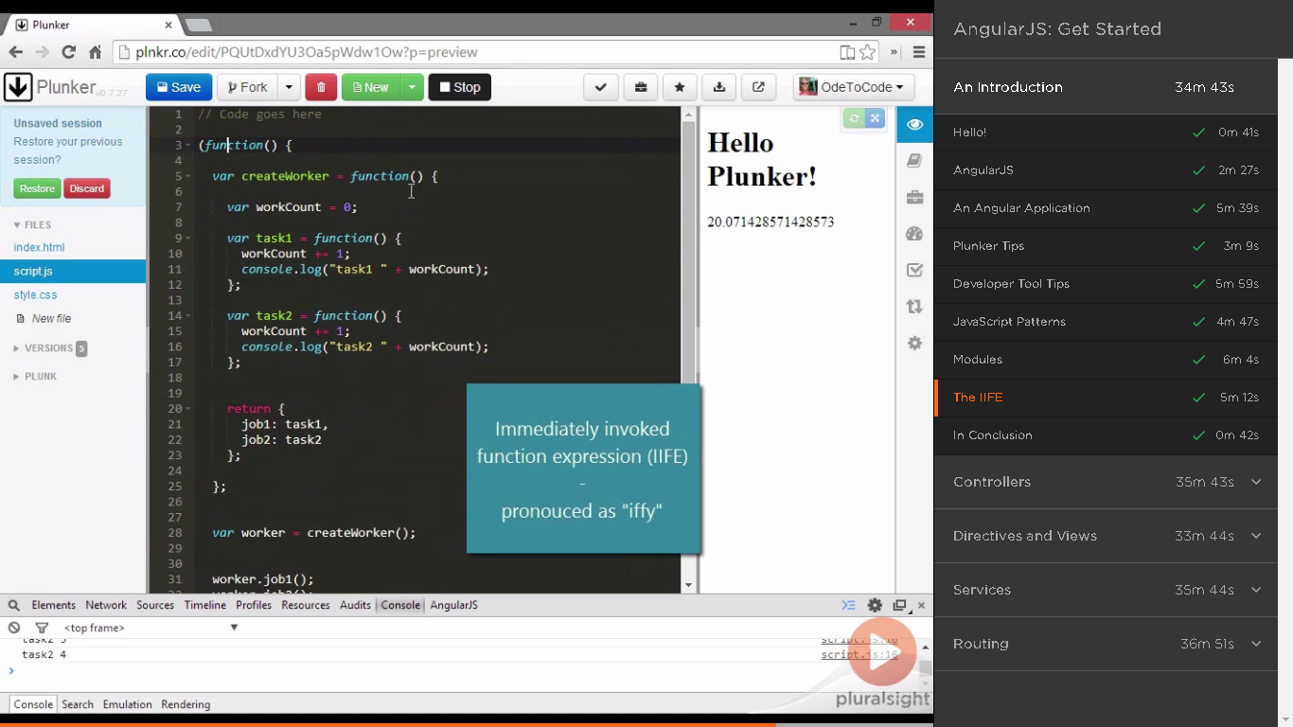

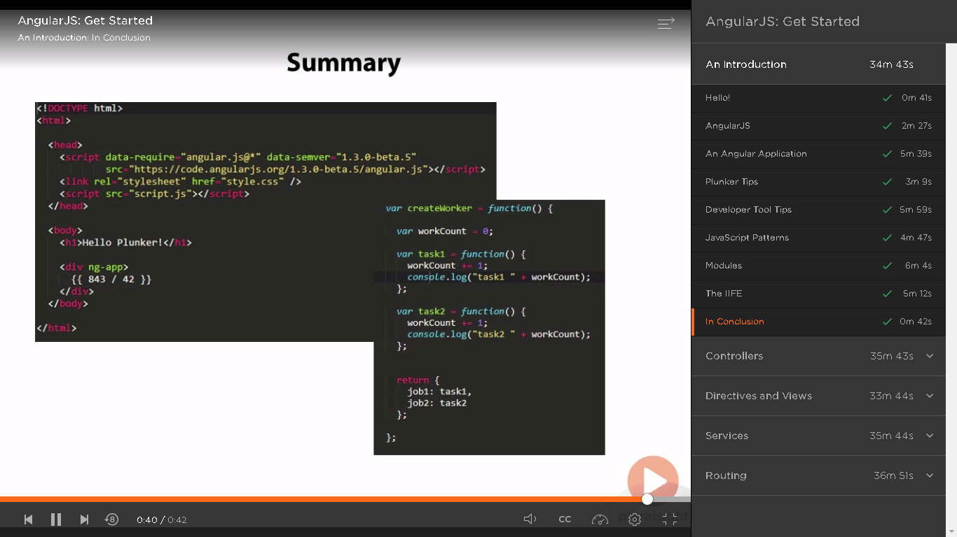

**Controllers**

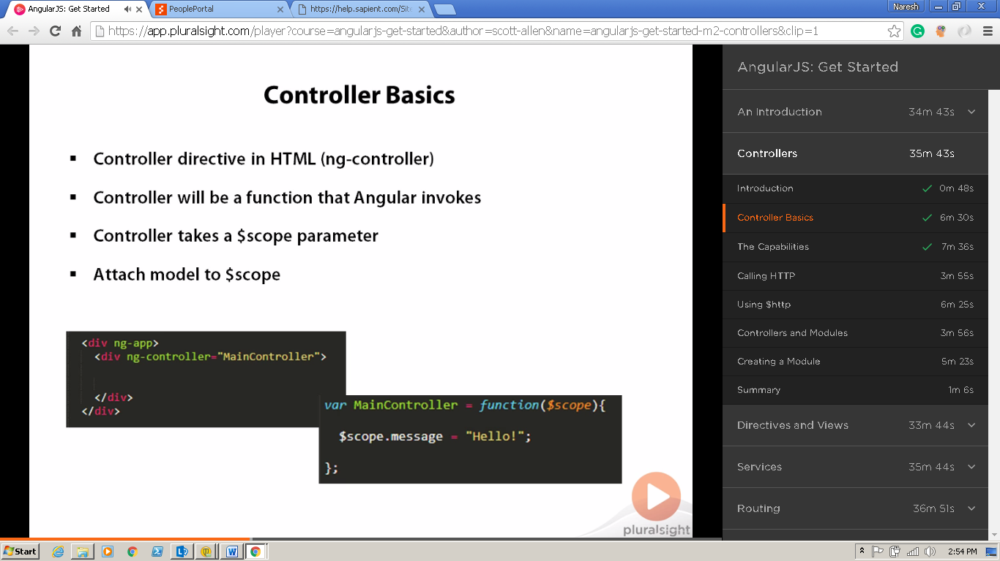

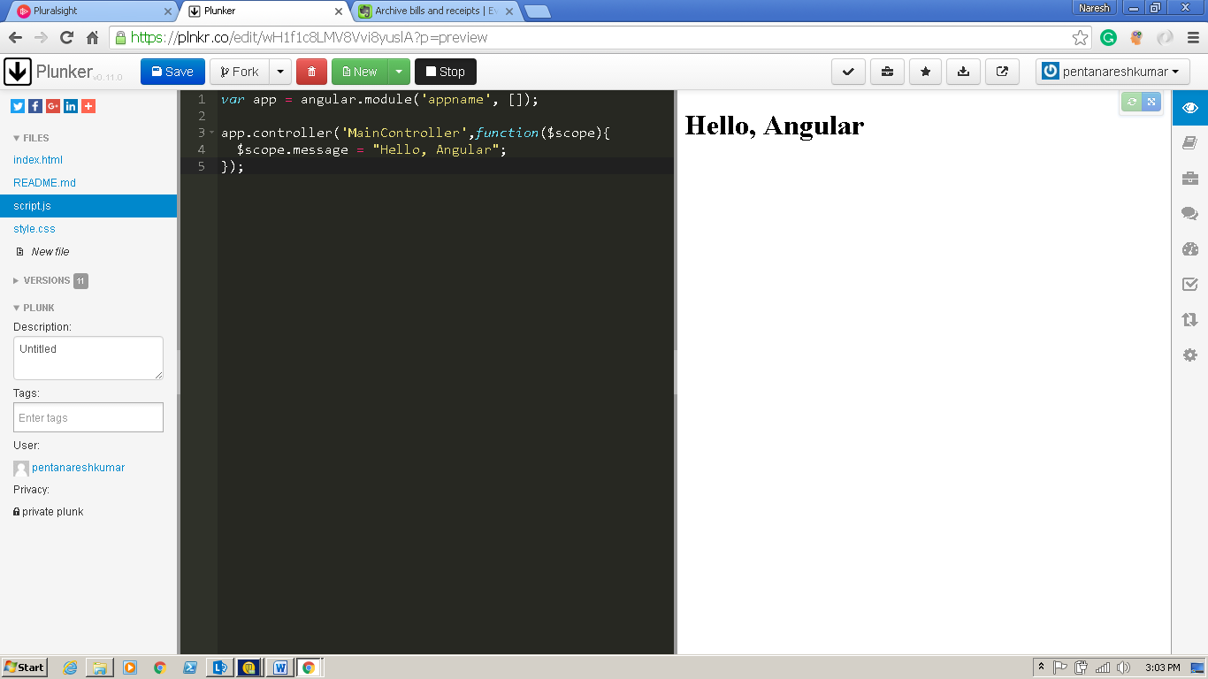

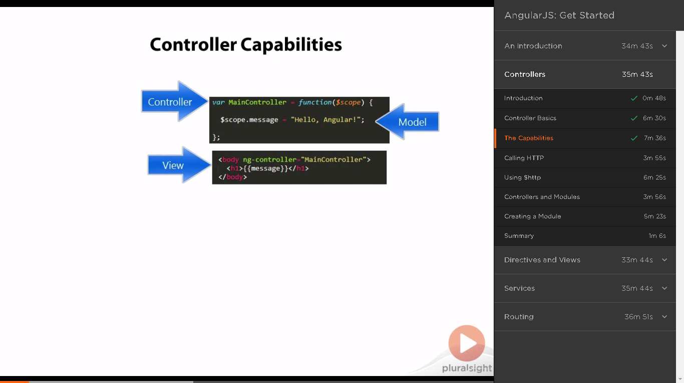

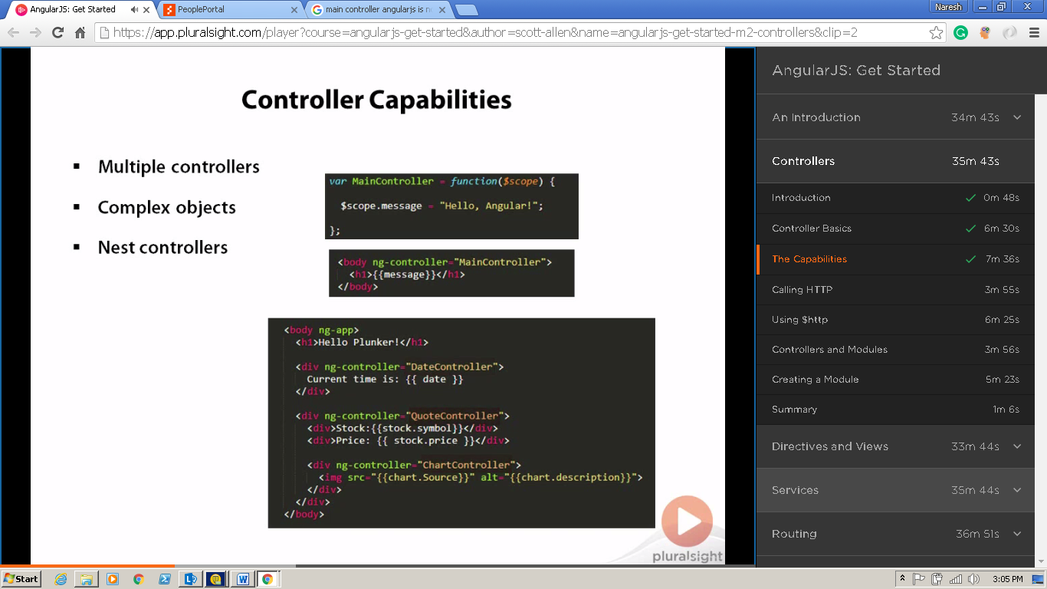

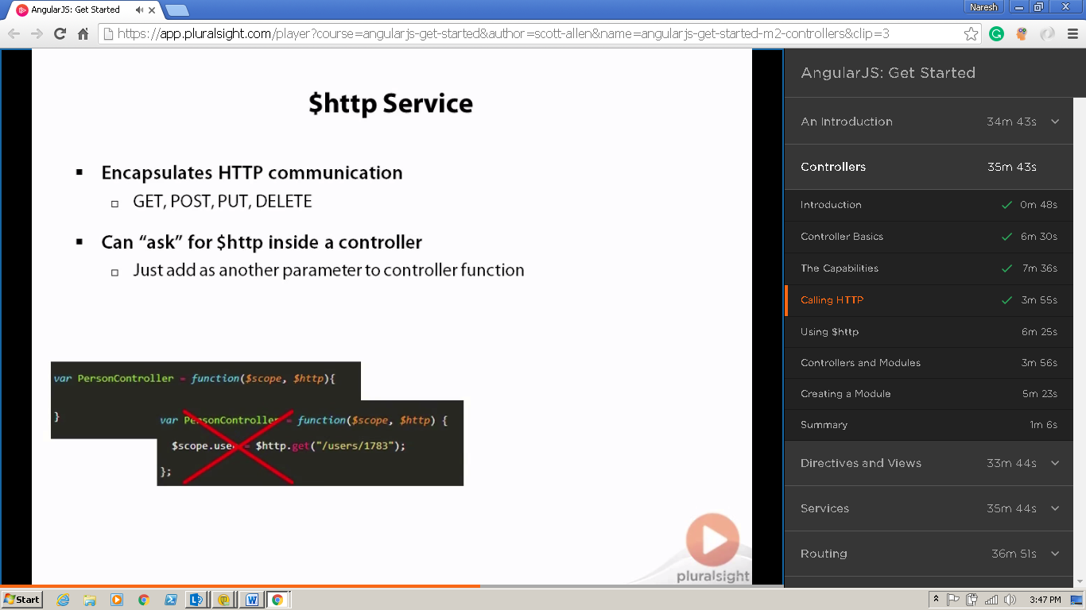

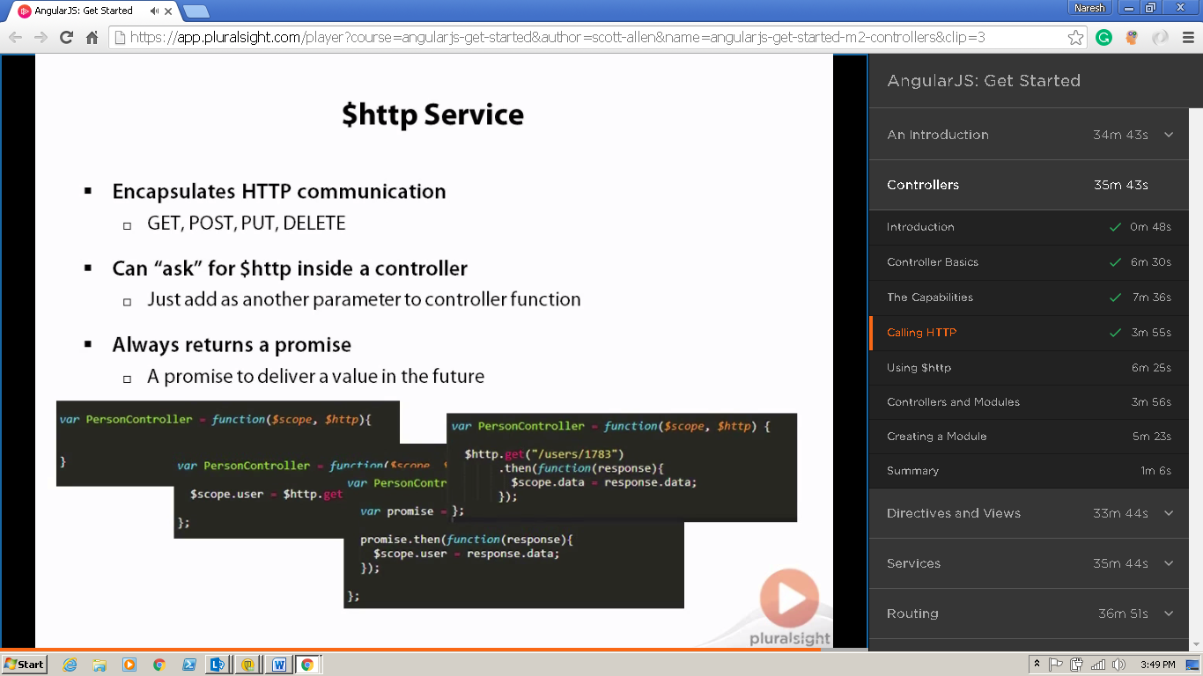

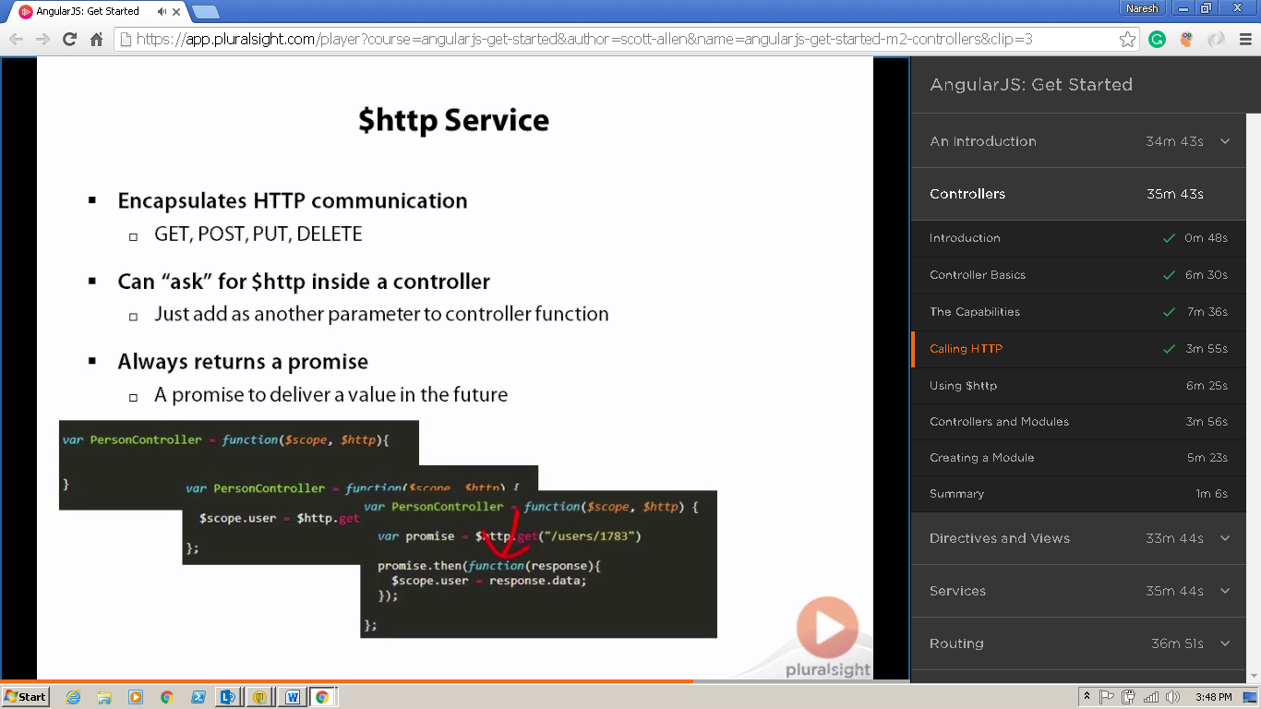

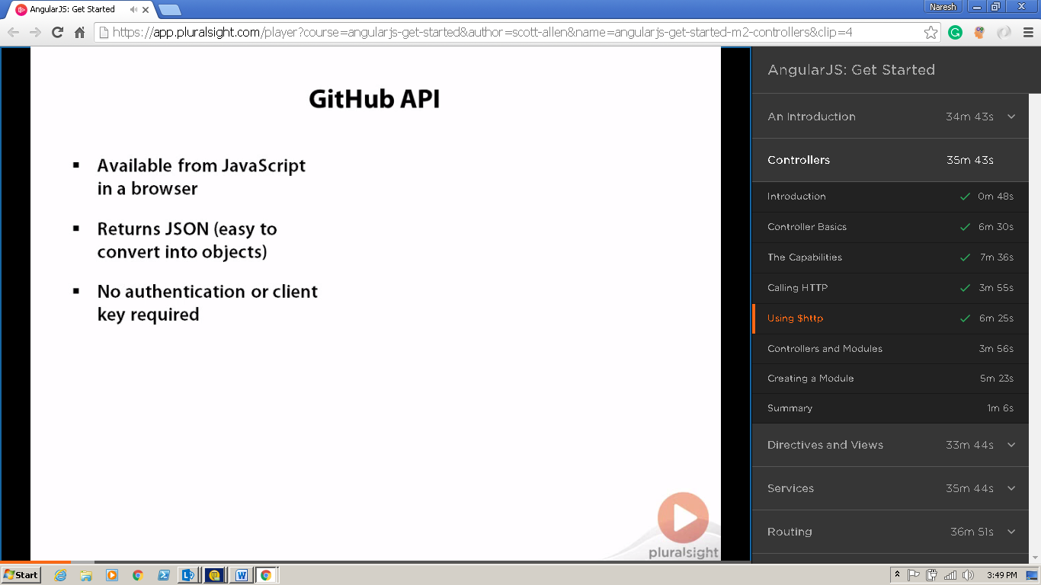

<https://api.github.com/users/odetocode>

{

* **login**: "OdeToCode",
* **id**: 137119,
* **avatar_url**: "<https://avatars.githubusercontent.com/u/137119?v=3>",
* **gravatar_id**: "",
* **url**: "<https://api.github.com/users/OdeToCode>",
* **html_url**: "<https://github.com/OdeToCode>",
* **followers_url**: "<https://api.github.com/users/OdeToCode/followers>",
* **following_url**: "[https://api.github.com/users/OdeToCode/following{/other_user}](https://api.github.com/users/OdeToCode/following%7B/other_user%7D)",
* **gists_url**: "[https://api.github.com/users/OdeToCode/gists{/gist_id}](https://api.github.com/users/OdeToCode/gists%7B/gist_id%7D)",
* **starred_url**: "[https://api.github.com/users/OdeToCode/starred{/owner}{/repo}](https://api.github.com/users/OdeToCode/starred%7B/owner%7D%7B/repo%7D)",
* **subscriptions_url**: "<https://api.github.com/users/OdeToCode/subscriptions>",
* **organizations_url**: "<https://api.github.com/users/OdeToCode/orgs>",
* **repos_url**: "<https://api.github.com/users/OdeToCode/repos>",
* **events_url**: "[https://api.github.com/users/OdeToCode/events{/privacy}](https://api.github.com/users/OdeToCode/events%7B/privacy%7D)",
* **received_events_url**: "<https://api.github.com/users/OdeToCode/received_events>",
* **type**: "User",
* **site_admin**: false,
* **name**: "K. Scott Allen",
* **company**: "OdeToCode",
* **blog**: "[http://OdeToCode.com/blogs/scott/](http://odetocode.com/blogs/scott/)",
* **location**: "Maryland",
* **email**: null,
* **hireable**: null,
* **bio**: null,
* **public_repos**: 41,
* **public_gists**: 23,
* **followers**: 602,
* **following**: 26,
* **created_at**: "2009-10-09T00:43:41Z",
* **updated_at**: "2016-06-13T13:20:13Z"

}

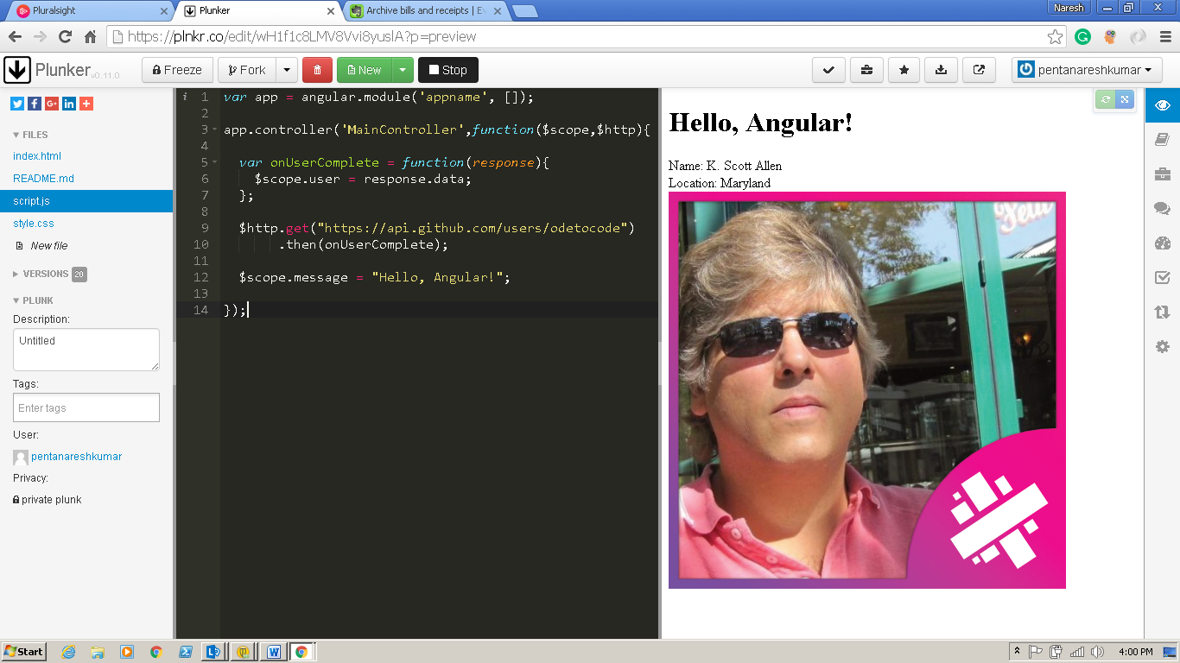

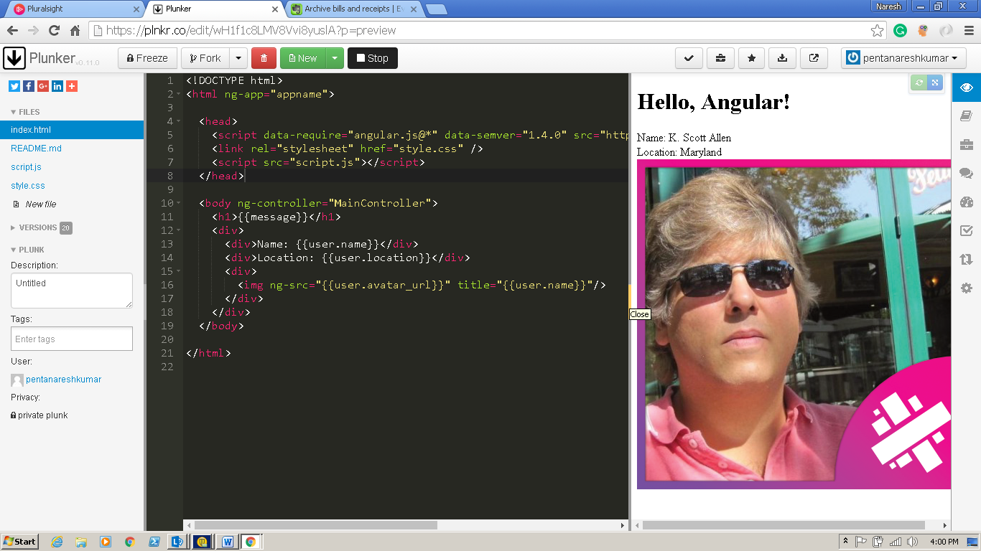

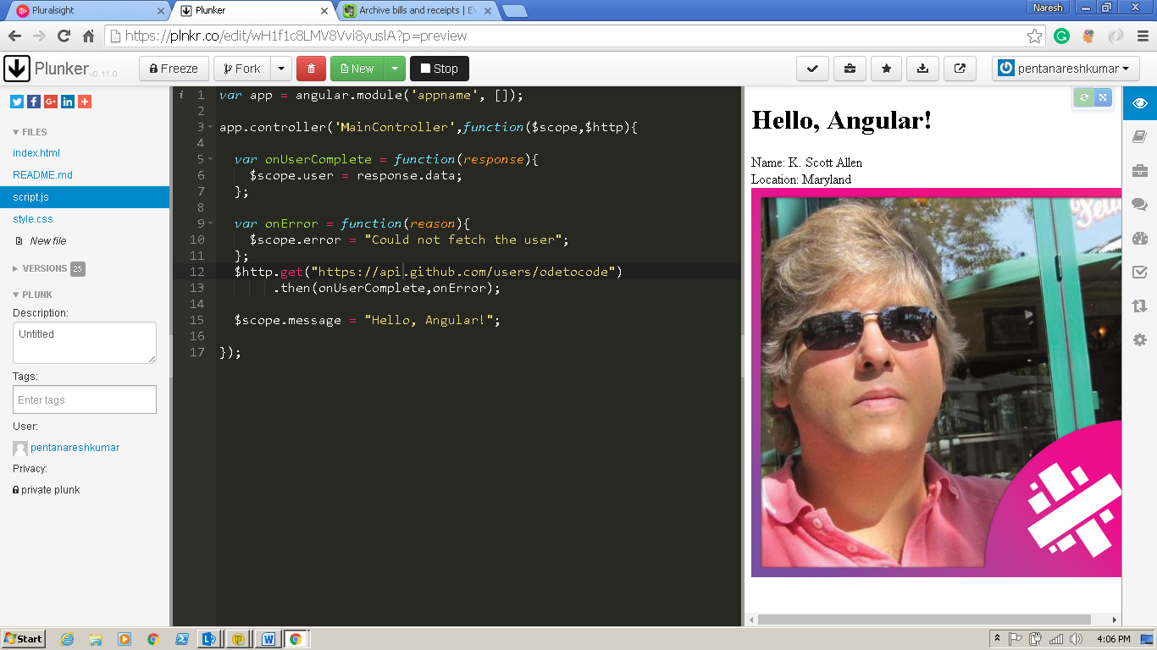

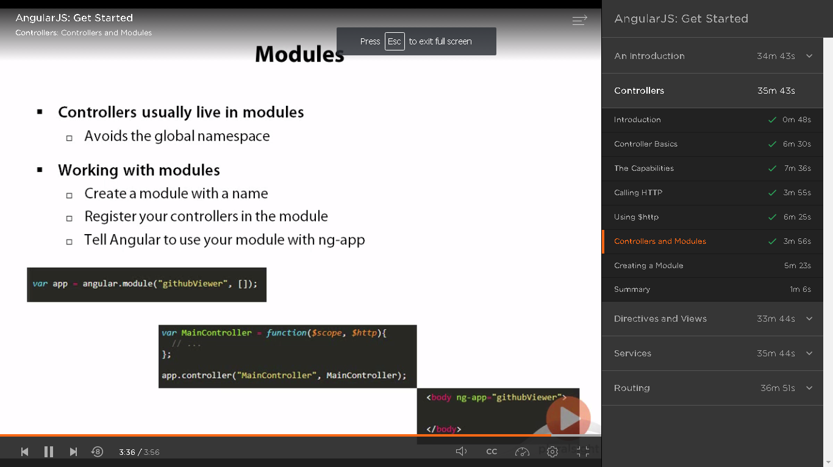

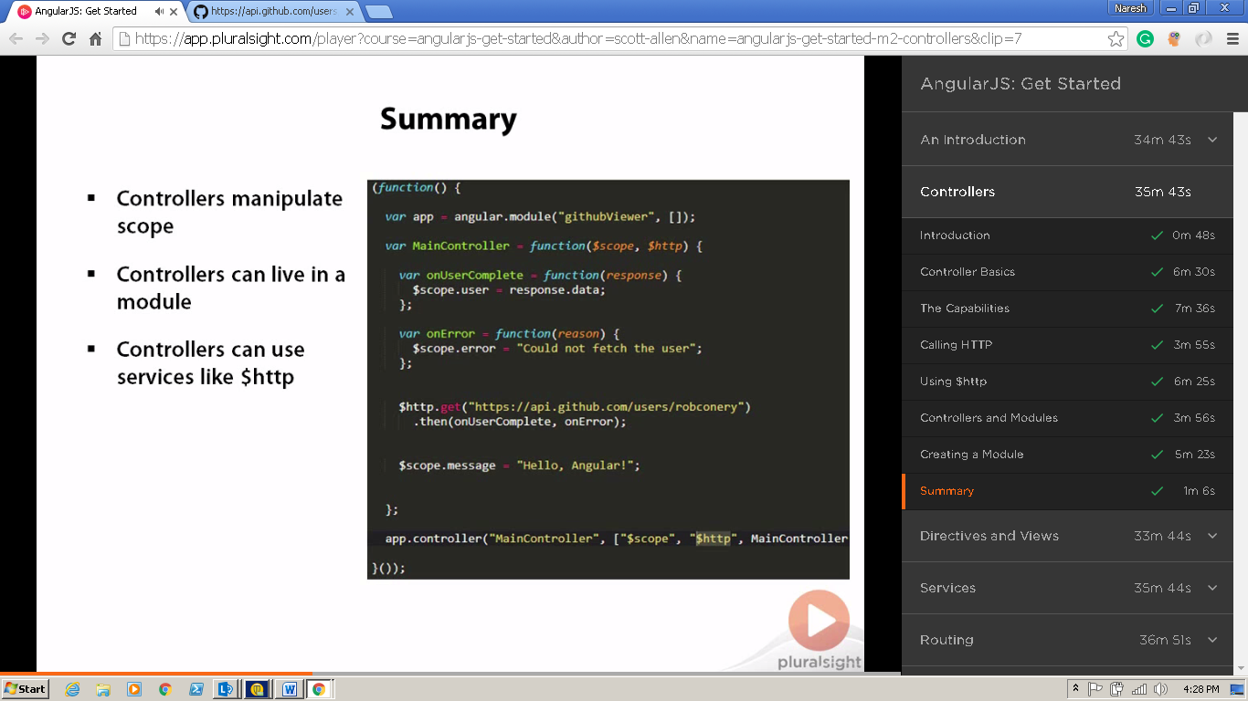

Directives

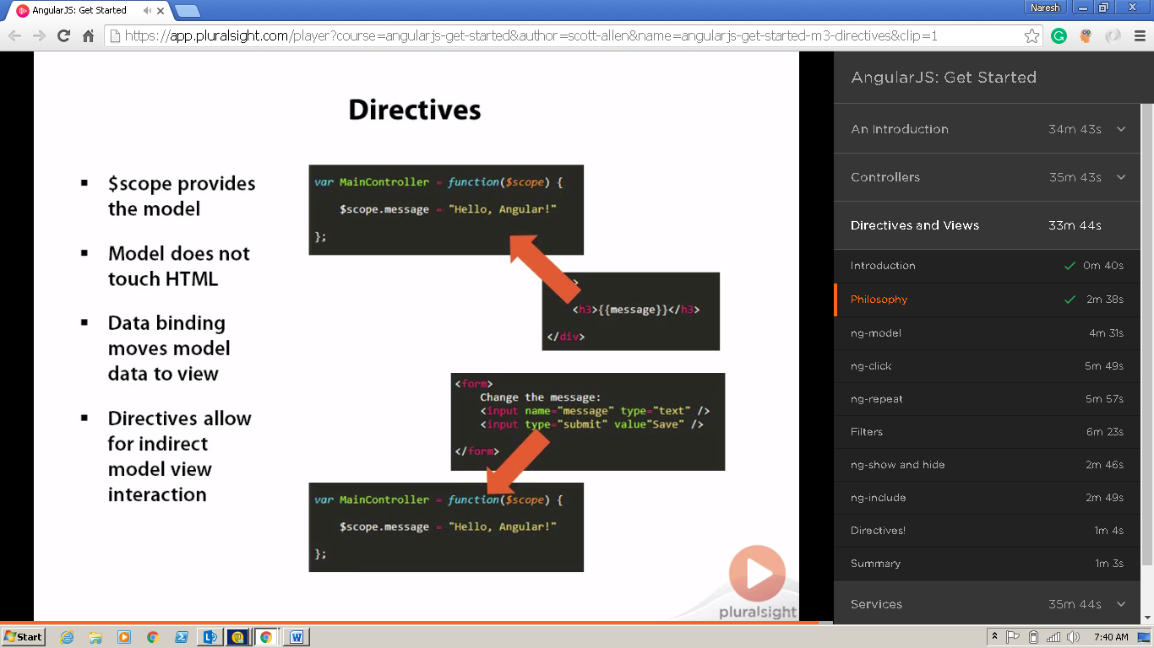

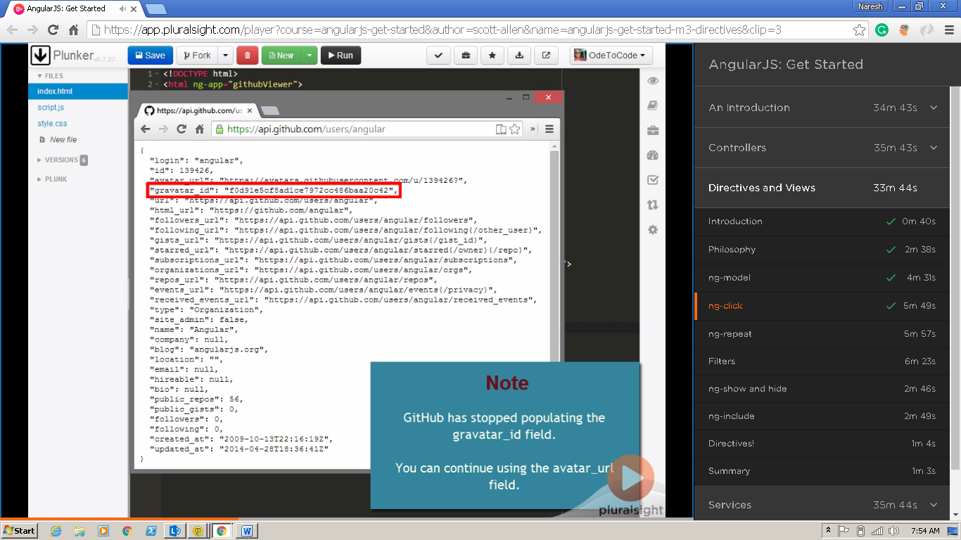

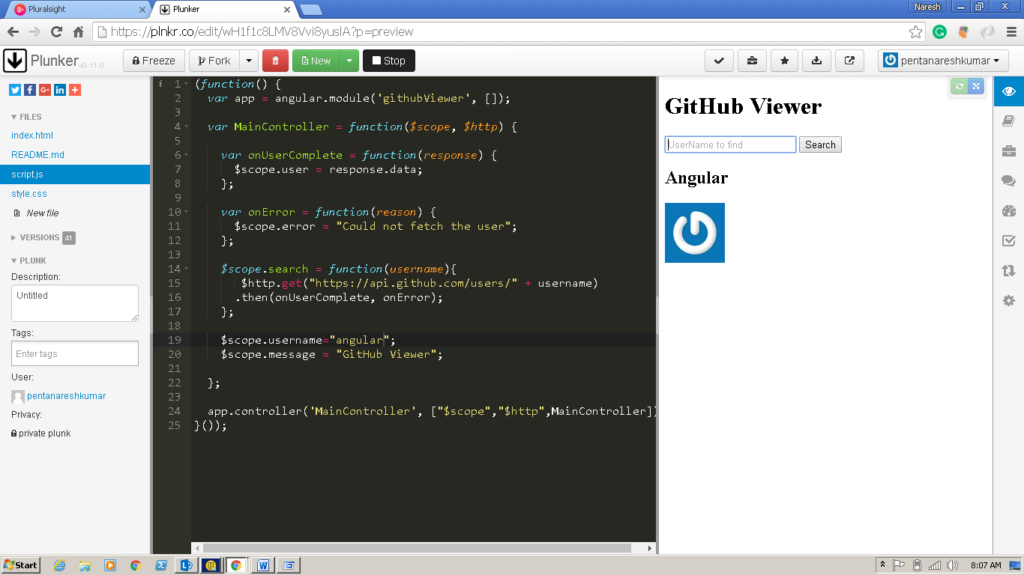

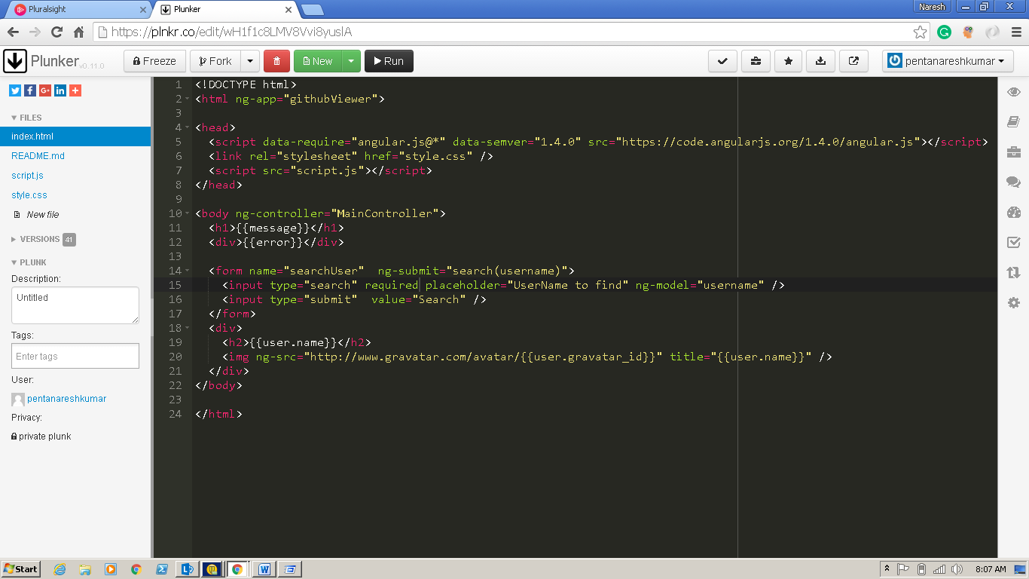

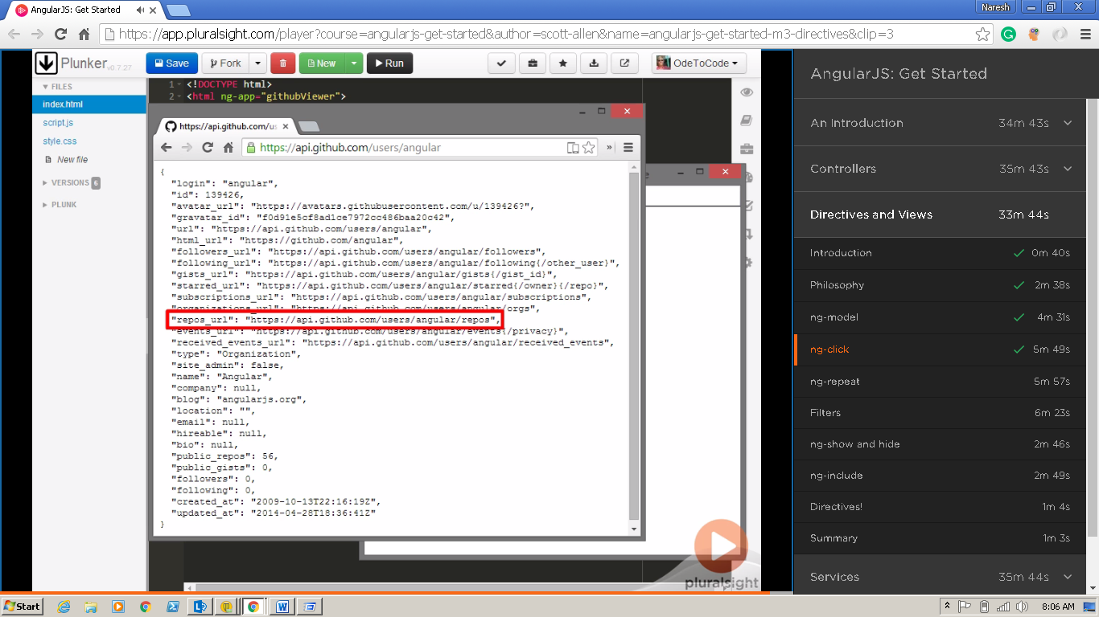

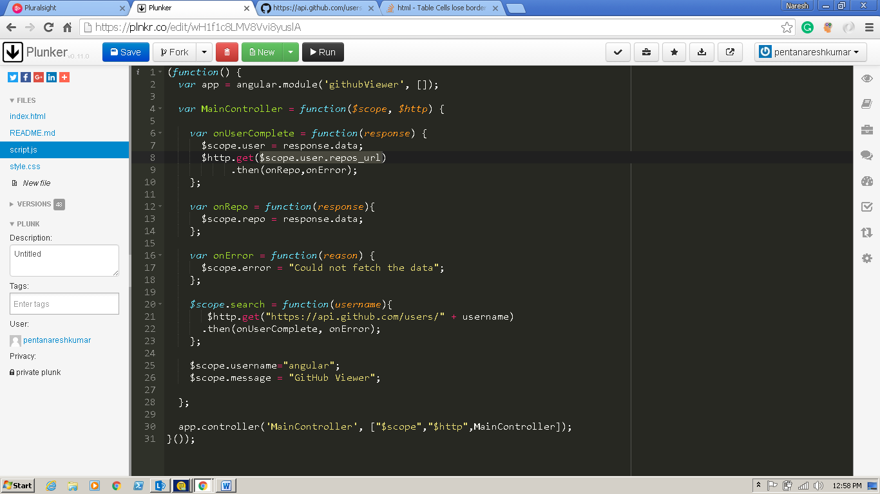

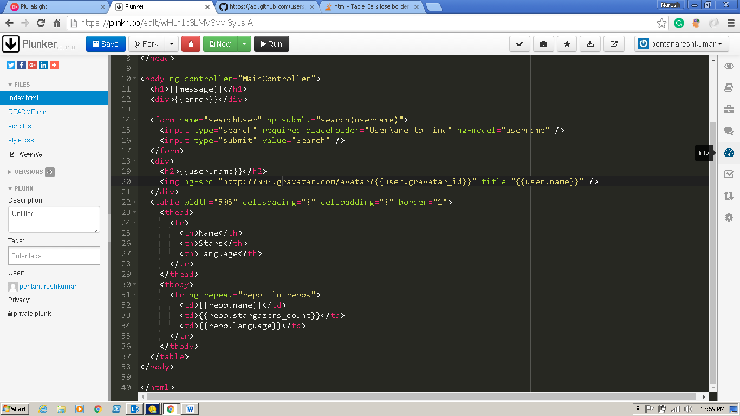

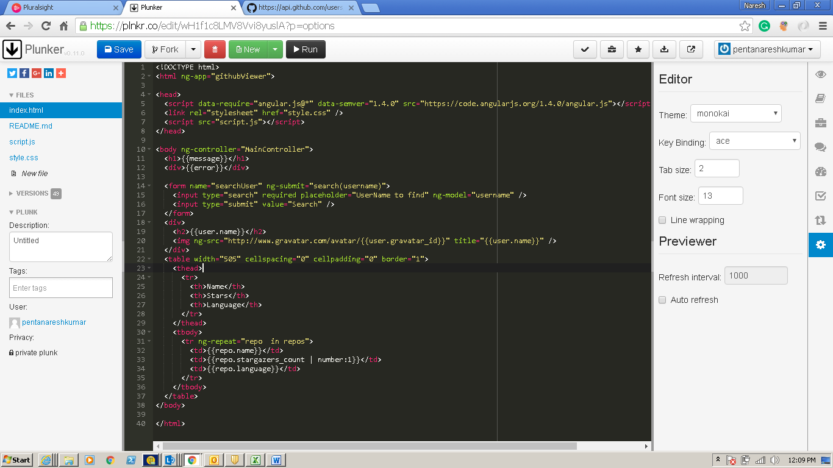

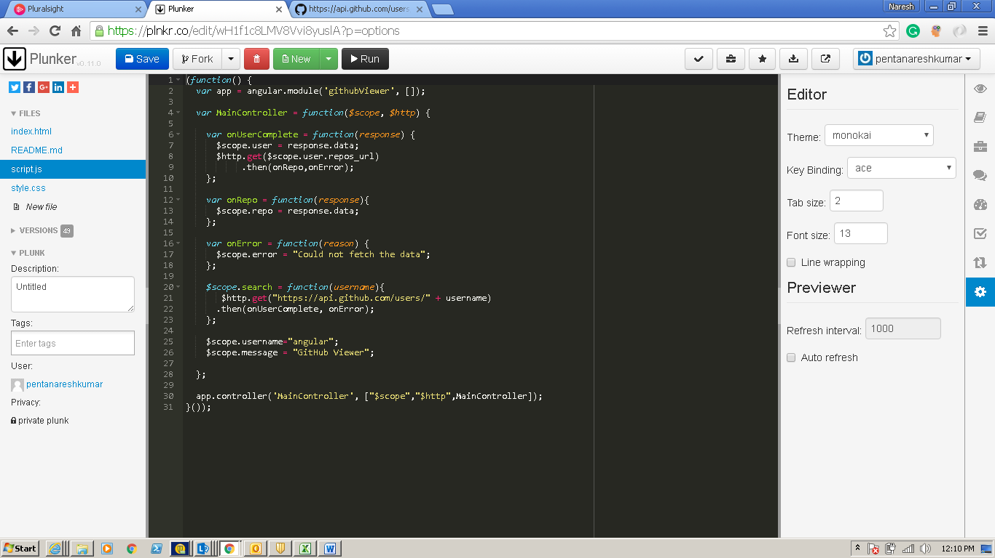

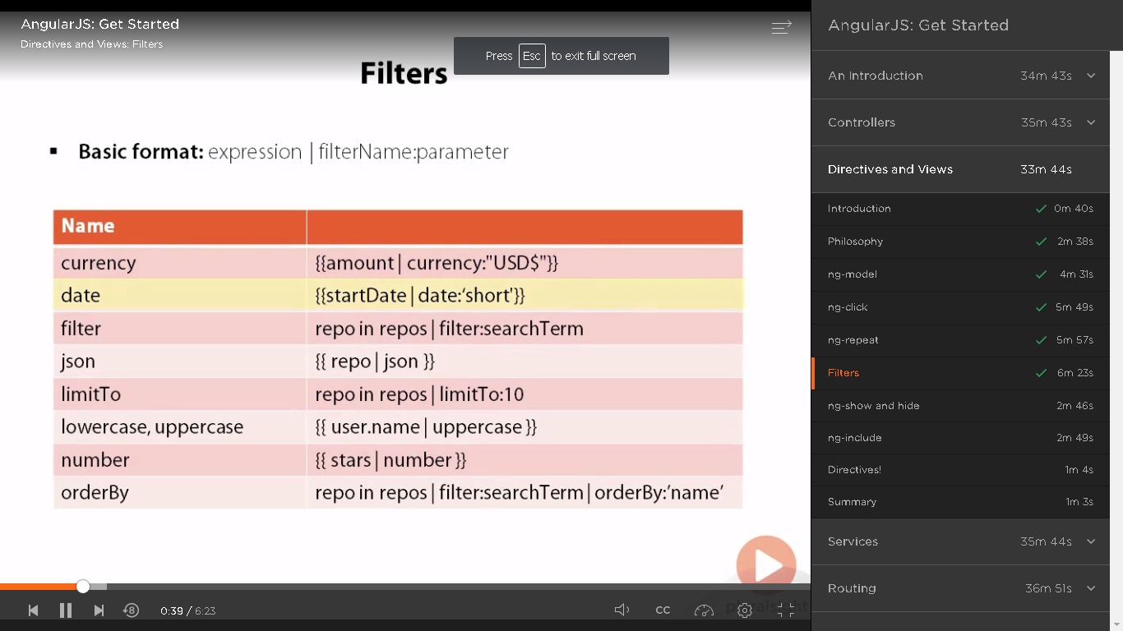

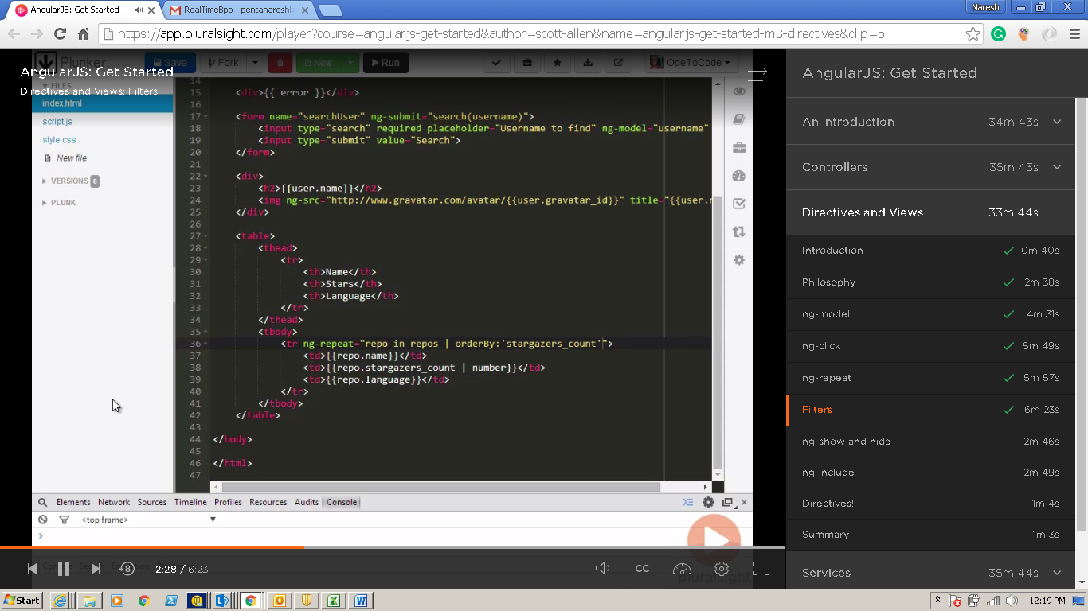

**Index.html**

<!DOCTYPE html>

<html ng-app="githubViewer">

<head>

<script data-require="angular.js@*" data-semver="1.4.0" src="https://code.angularjs.org/1.4.0/angular.js"></script>

<link rel="stylesheet" href="style.css" />

<script src="script.js"></script>

</head>

<body ng-controller="MainController">

<h1>{{message}}</h1>

<div>{{error}}</div>

<form name="searchUser" ng-submit="search(username)">

<input type="search" required placeholder="UserName to find" ng-model="username" />

<input type="submit" value="Search" />

</form>

<div>

<h2>{{user.name}}</h2>

<img ng-src="http://www.gravatar.com/avatar/{{user.gravatar_id}}" title="{{user.name}}" />

</div>

Order:

<select ng-model="repoSortOrder">

<option value="+name">Name</option>

<option value="-stargazers_count">Stars</option>

<option value="+language">Language</option>

</select>

<table width="505" cellspacing="0" cellpadding="0" border="1">

<thead>

<tr>

<th>Name</th>

<th>Stars</th>

<th>Language</th>

</tr>

</thead>

<tbody>

<tr ng-repeat="repo in repos | orderBy:repoSortOrder">

<td>{{repo.name}}</td>

<td>{{repo.stargazers_count | number}}</td>

<td>{{repo.language}}</td>

</tr>

</tbody>

</table>

</body>

</html>

**Script.js**

(function() {

var app = angular.module('githubViewer', []);

var MainController = function($scope, $http) {

var onUserComplete = function(response) {

$scope.user = response.data;

$http.get(response.data.repos_url)

.then(onRepo,onError);

};

var onRepo = function(response){

$scope.repos = response.data;

};

var onError = function(reason) {

$scope.error = "Could not fetch the data";

};

$scope.search = function(username){

$http.get("https://api.github.com/users/" + username)

.then(onUserComplete, onError);

};

$scope.username="angular";

$scope.message = "GitHub Viewer";

$scope.repoSortOrder ="-stargazers_count";

};

app.controller('MainController', ["$scope","$http",MainController]);

}());

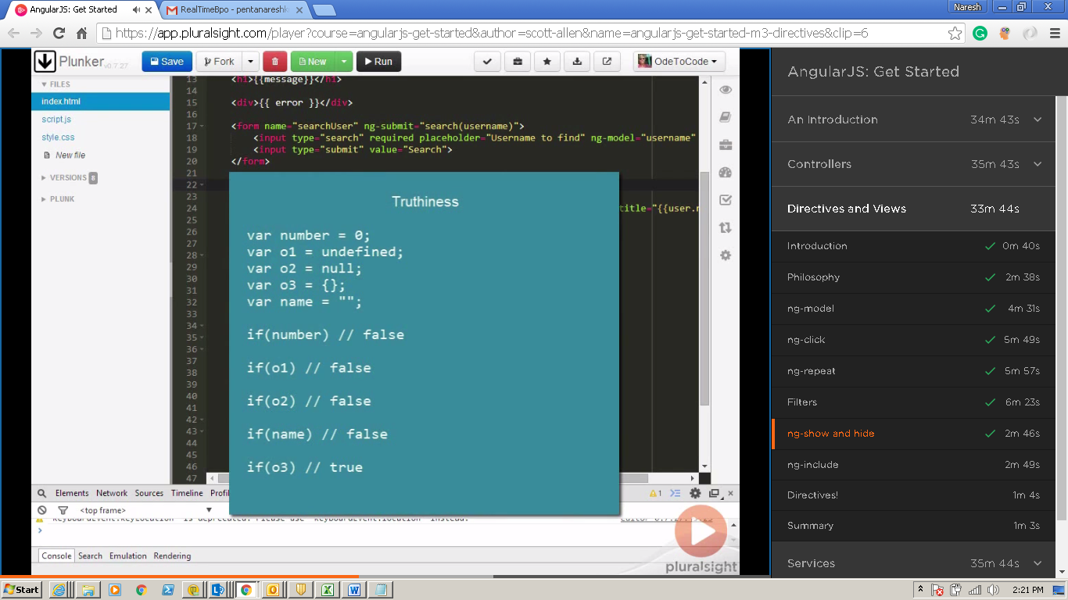

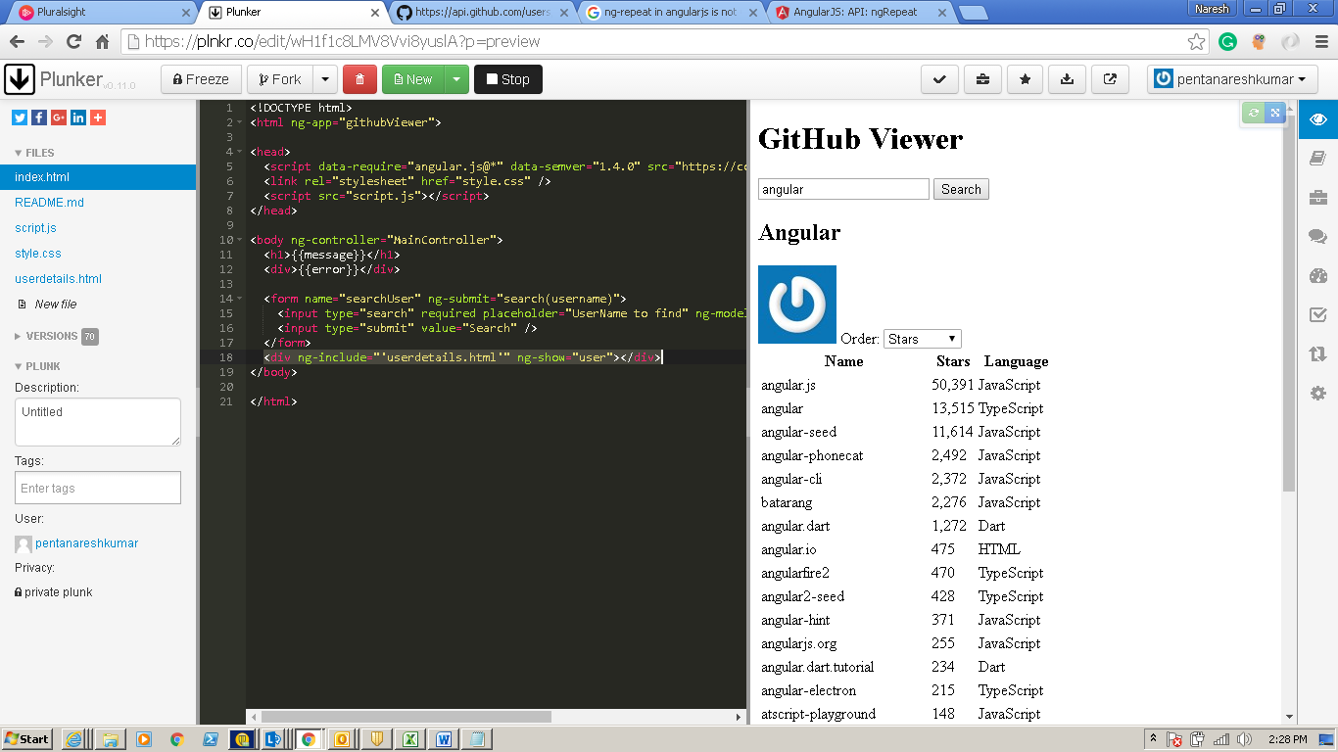

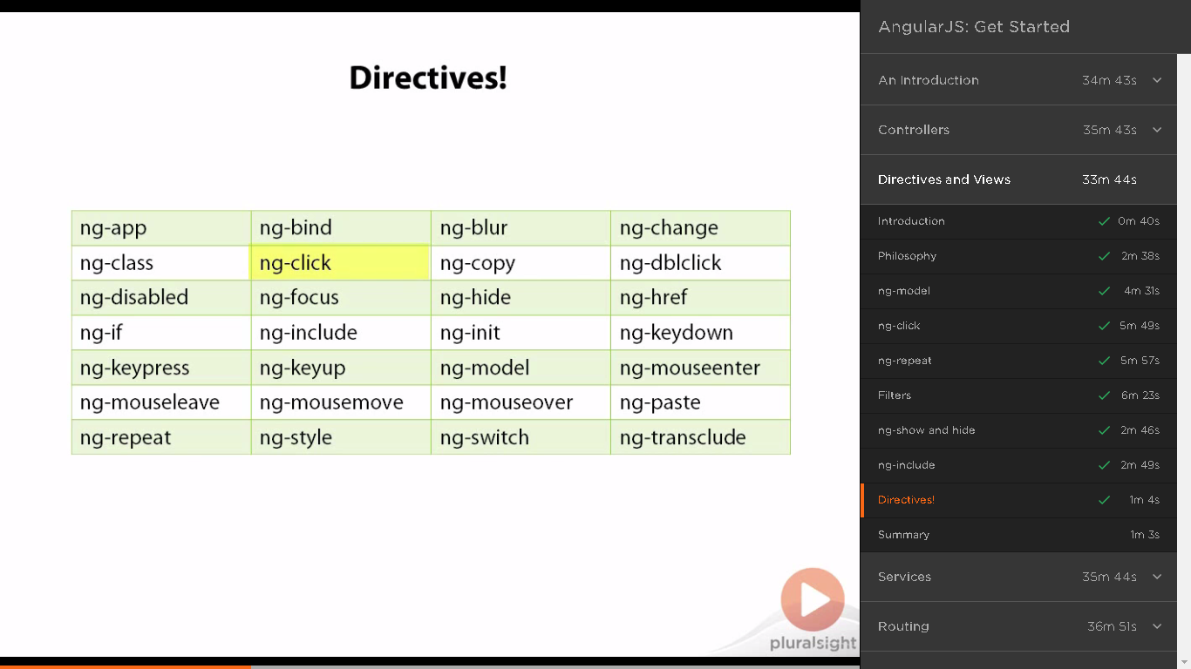

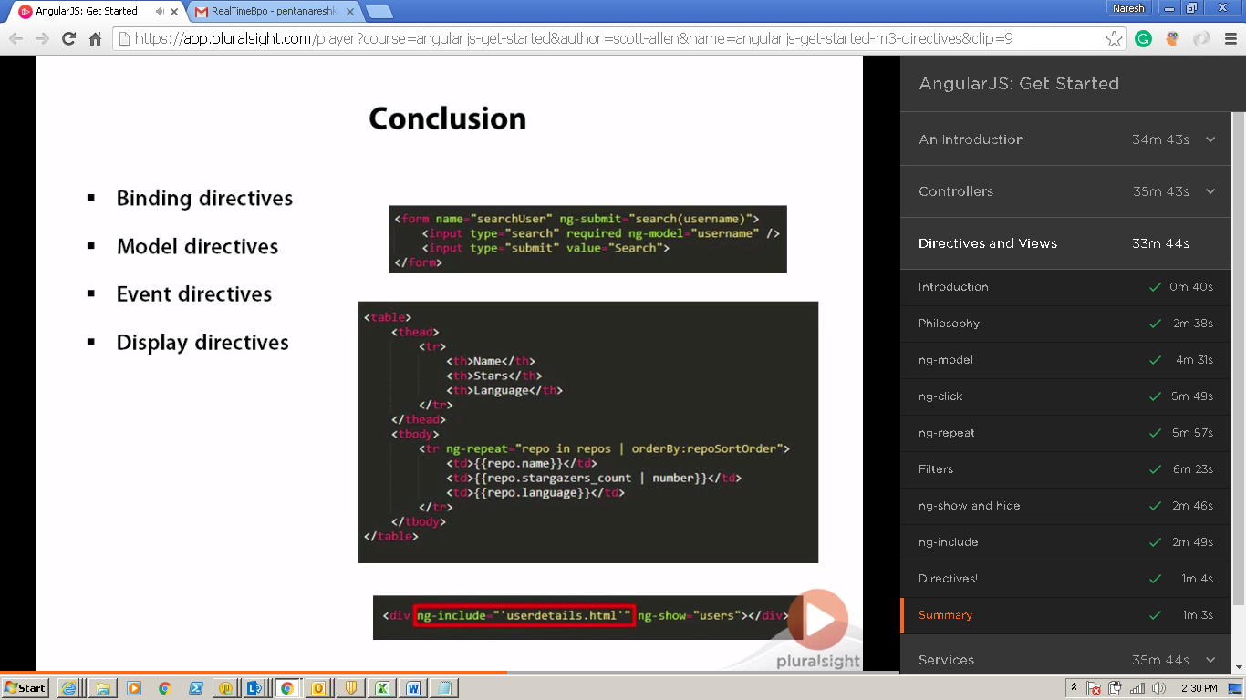

**Services**

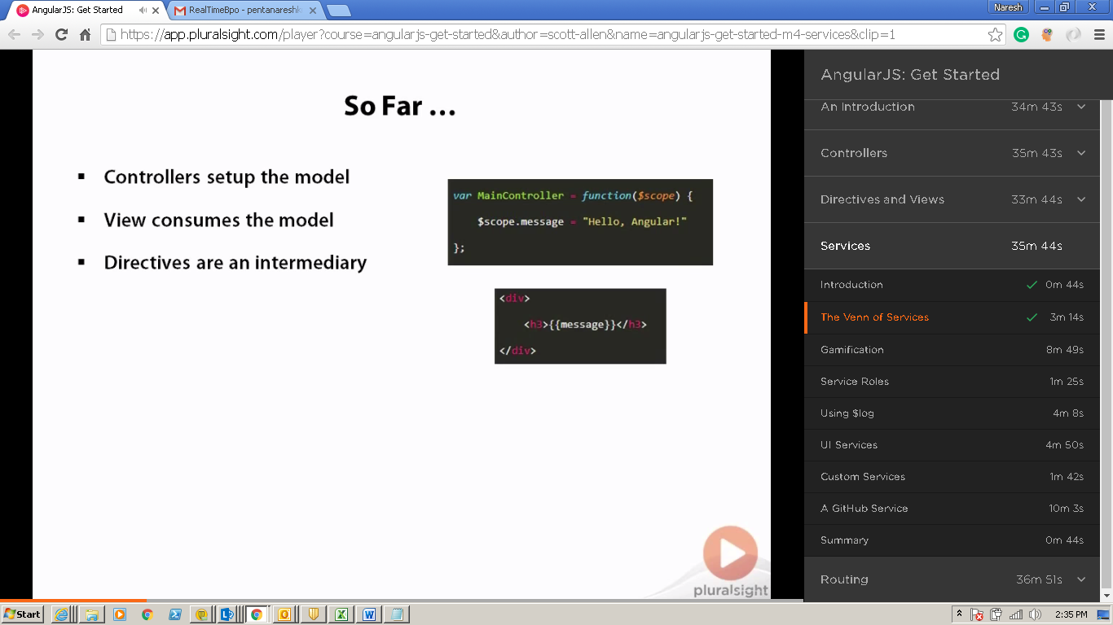

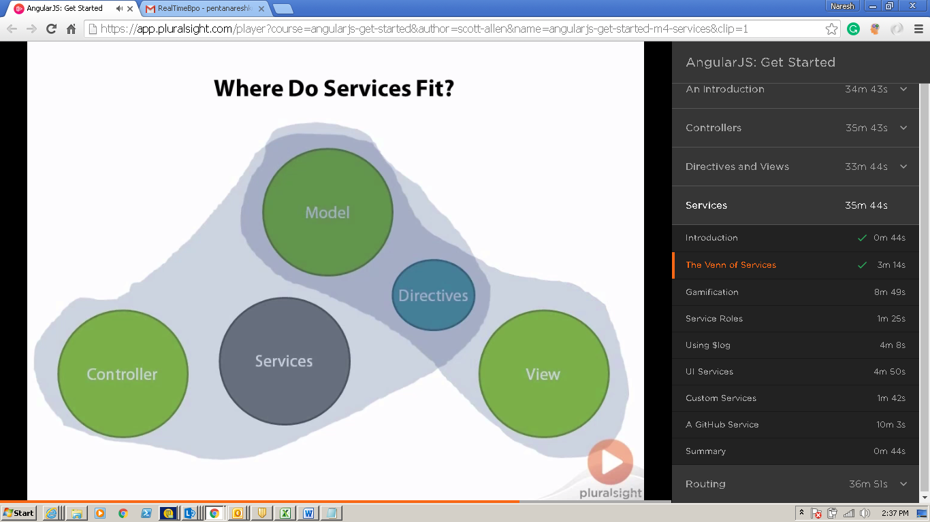

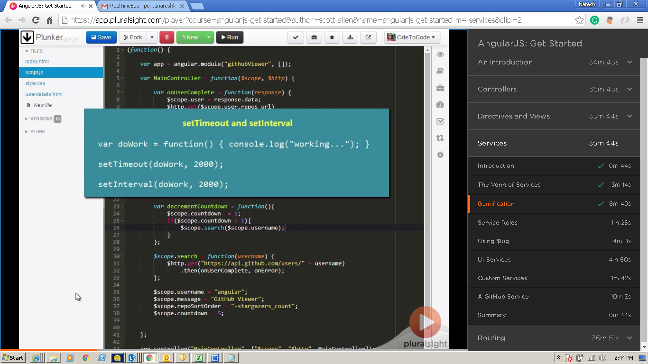

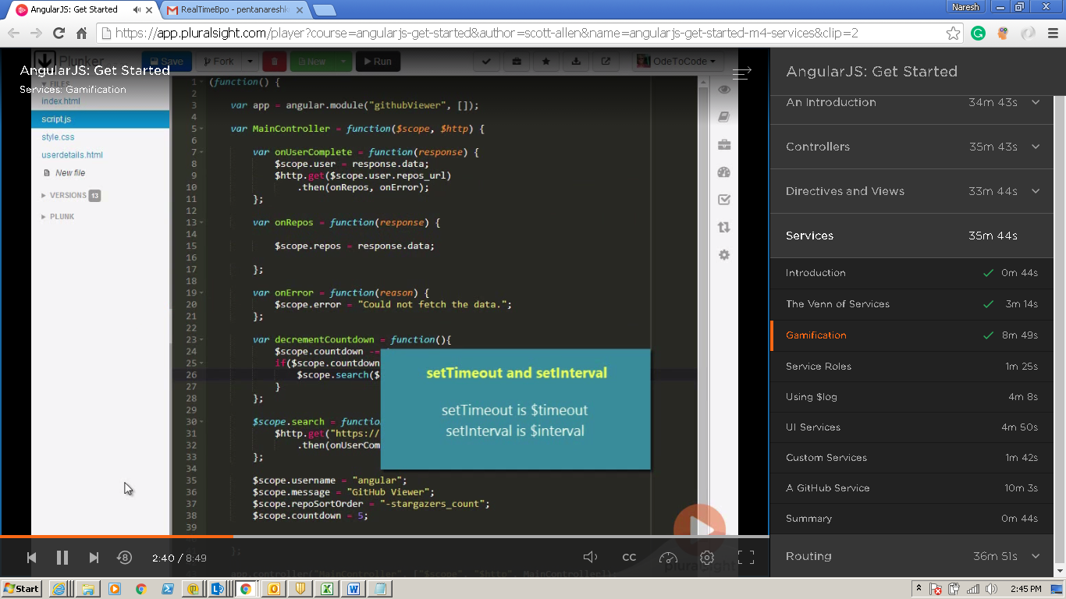

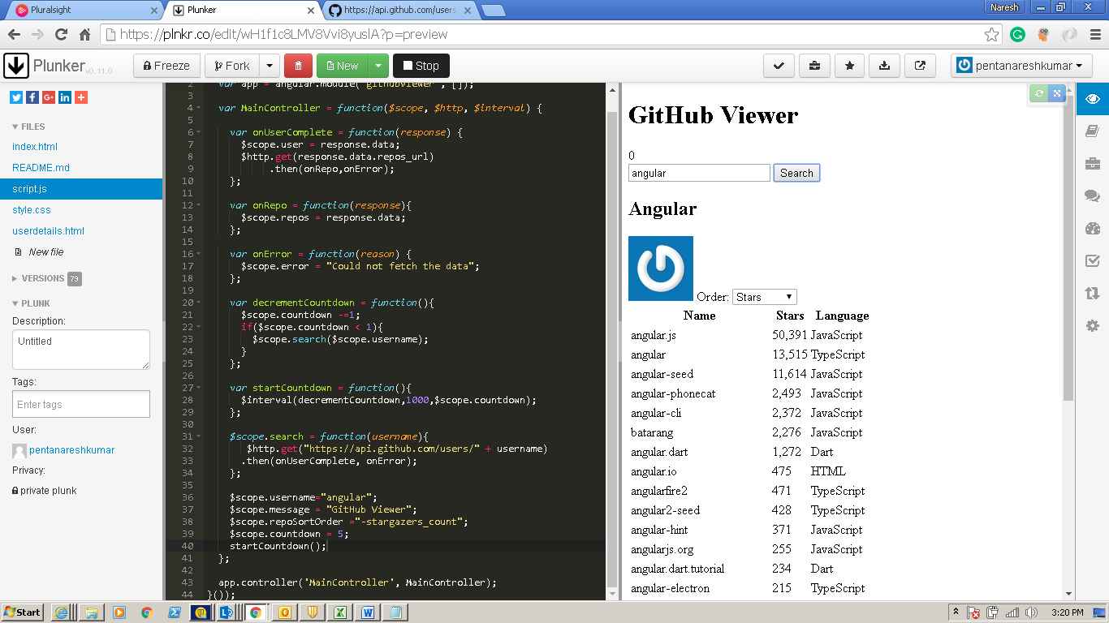

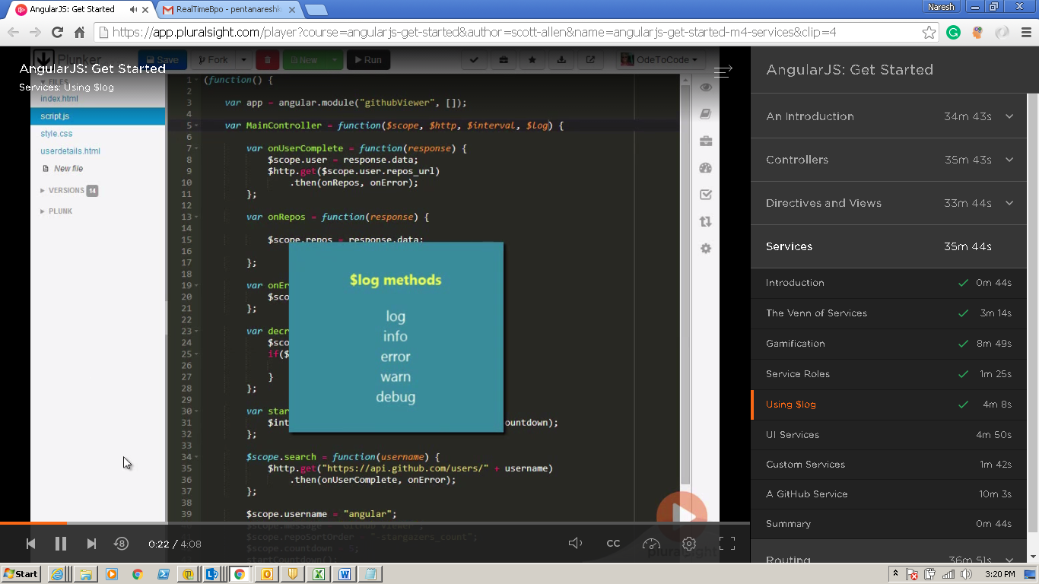

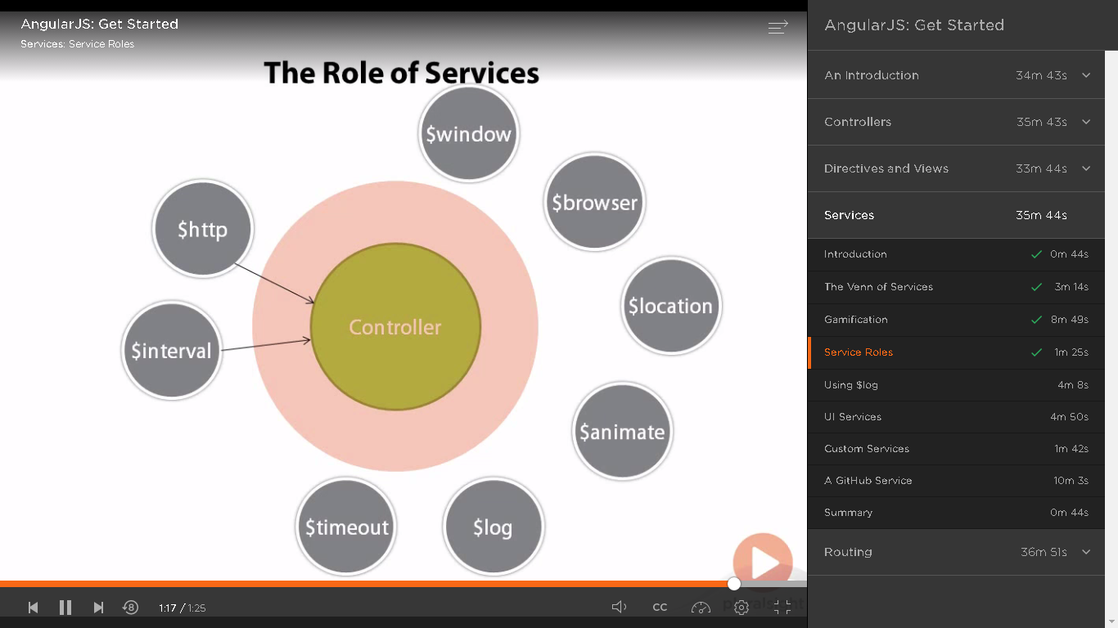

**(function() {**

**var app = angular.module('githubViewer', []);**

**var MainController = function($scope, $http, $interval,$log) {**

**var onUserComplete = function(response) {**

**$scope.user = response.data;**

**$http.get(response.data.repos_url)**

**.then(onRepo,onError);**

**};**

**var onRepo = function(response){**

**$scope.repos = response.data;**

**};**

**var onError = function(reason) {**

**$scope.error = "Could not fetch the data";**

**};**

**var decrementCountdown = function(){**

**$scope.countdown -=1;**

**if($scope.countdown < 1){**

**$scope.search($scope.username);**

**}**

**};**

**var startCountdown = function(){**

**countdownInterval = $interval(decrementCountdown,1000,$scope.countdown);**

**};**

**$scope.search = function(username){**

**$log.info("searching for " + username )**

**$http.get("https://api.github.com/users/" + username)**

**.then(onUserComplete, onError);**

**if(countdownInterval){**

**$interval.cancel(countdownInterval);**

**$scope.countdown = null;**

**}**

**};**

**$scope.username="angular";**

**$scope.message = "GitHub Viewer";**

**$scope.repoSortOrder ="-stargazers_count";**

**$scope.countdown = 5;**

**startCountdown();**

**};**

**app.controller('MainController', MainController);**

**}());**

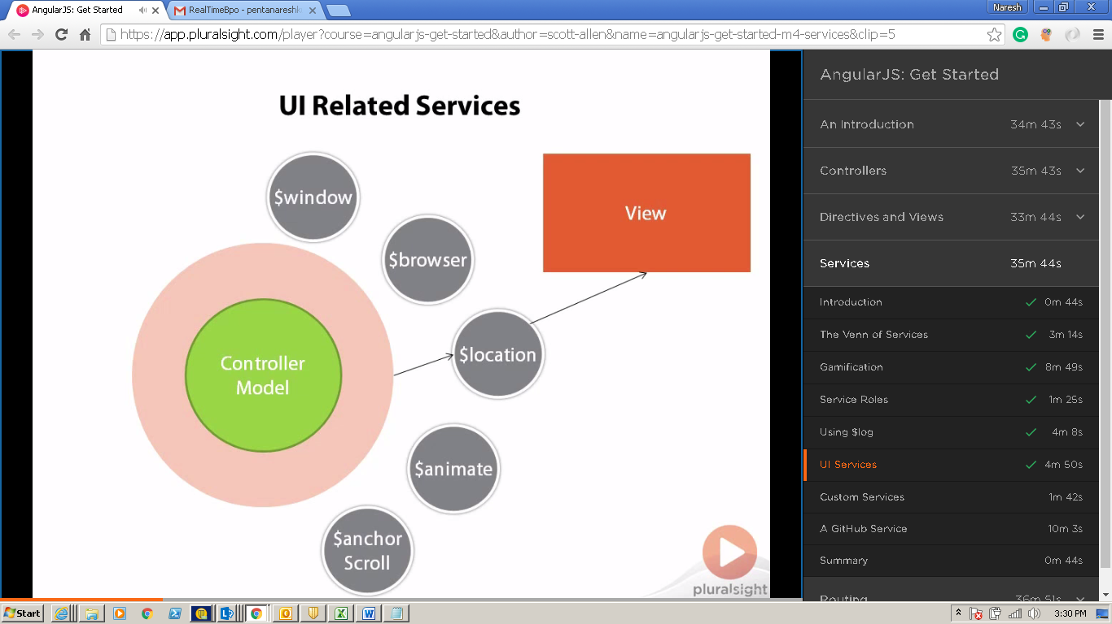

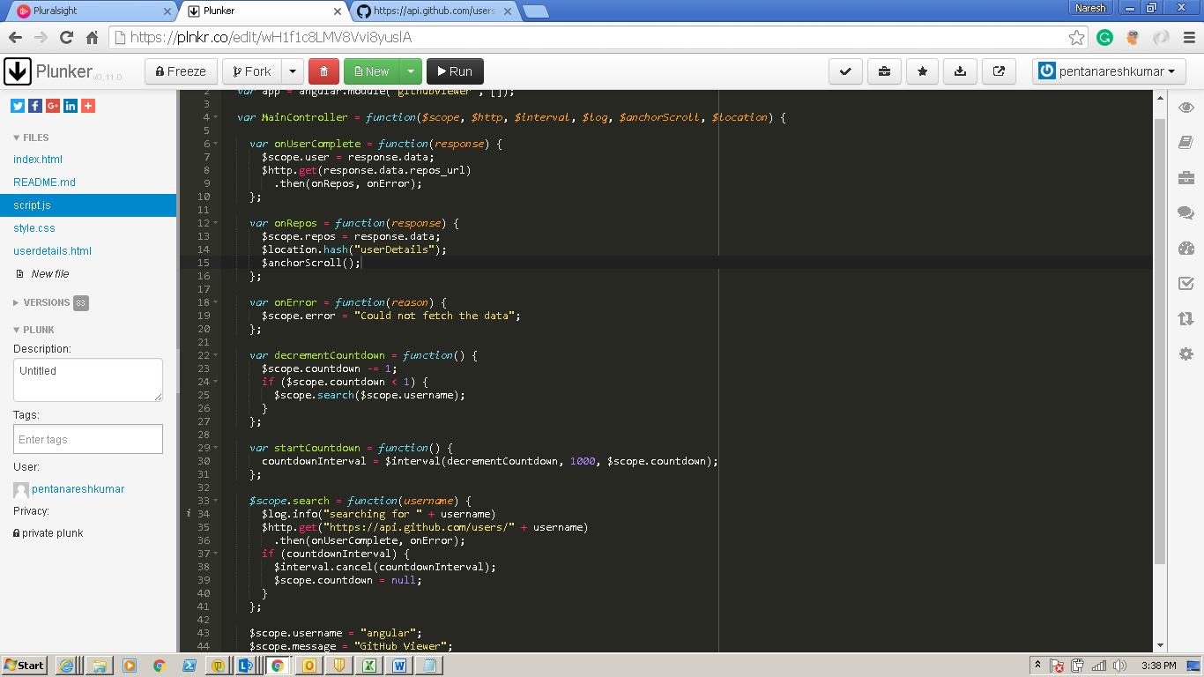

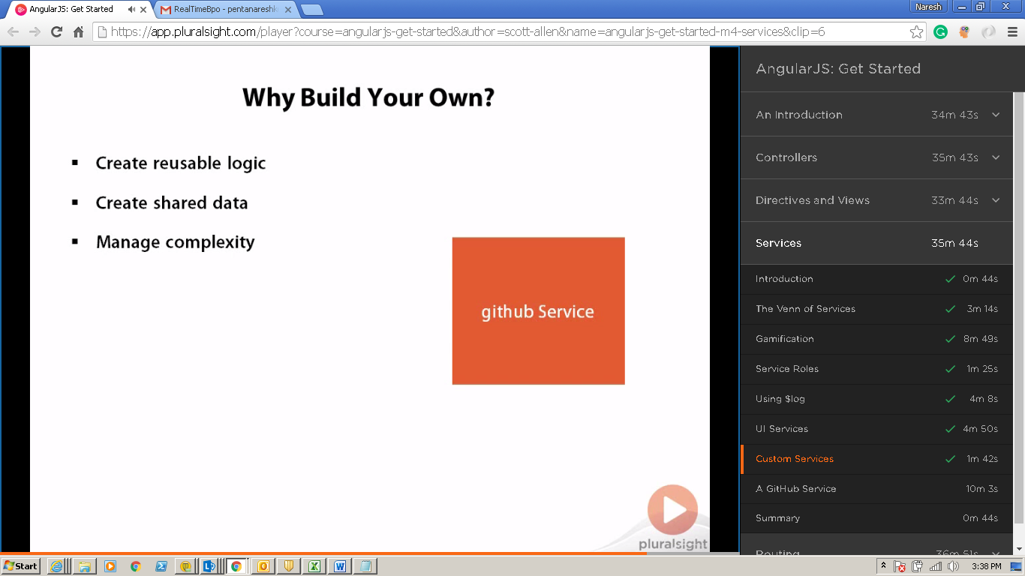

**Routing**

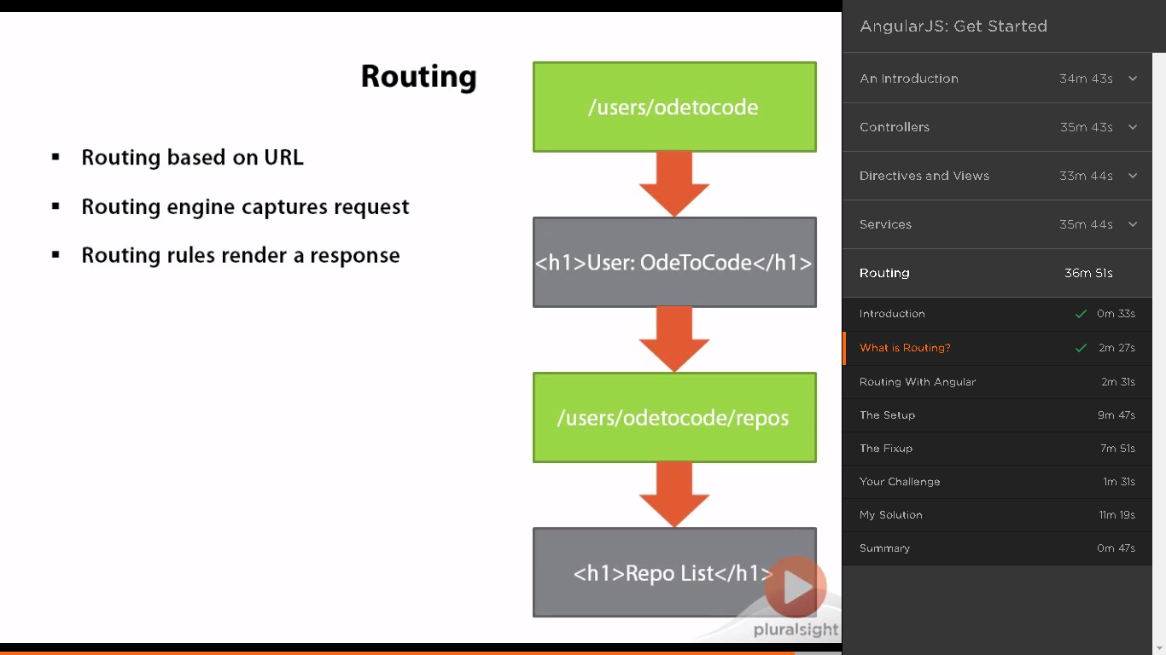

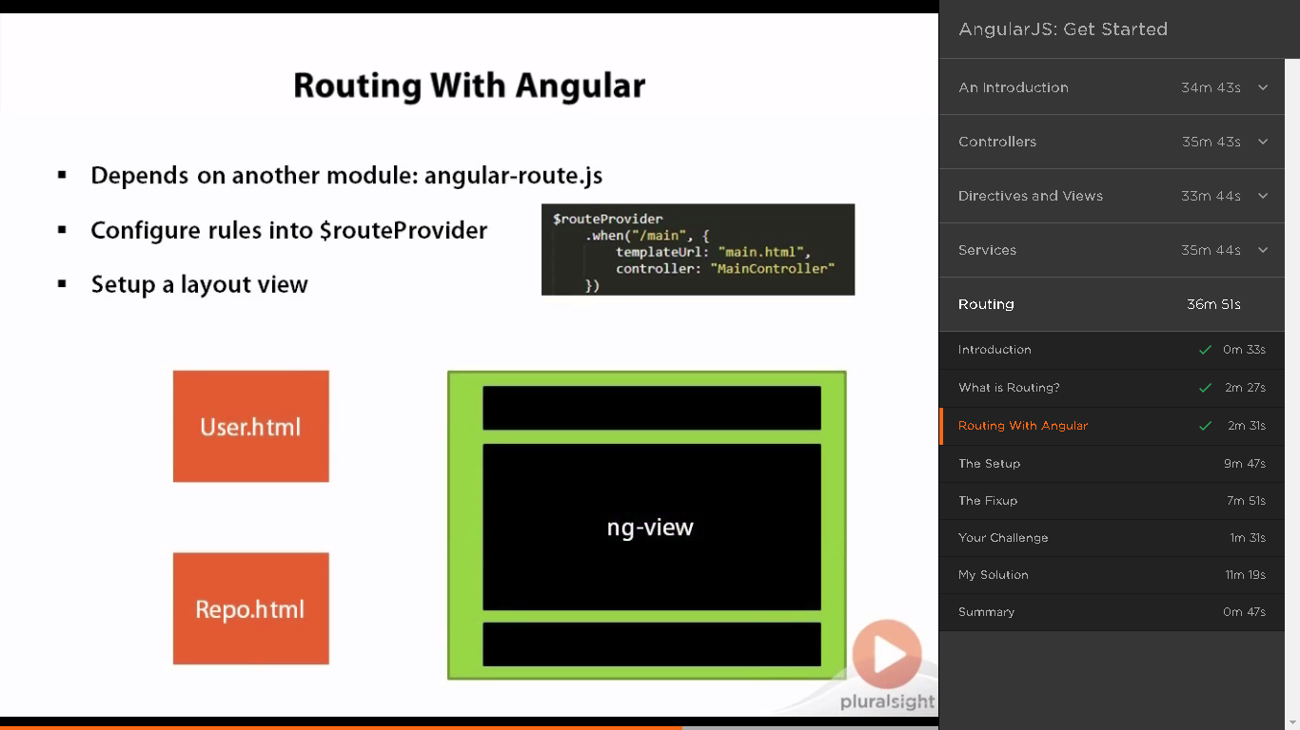

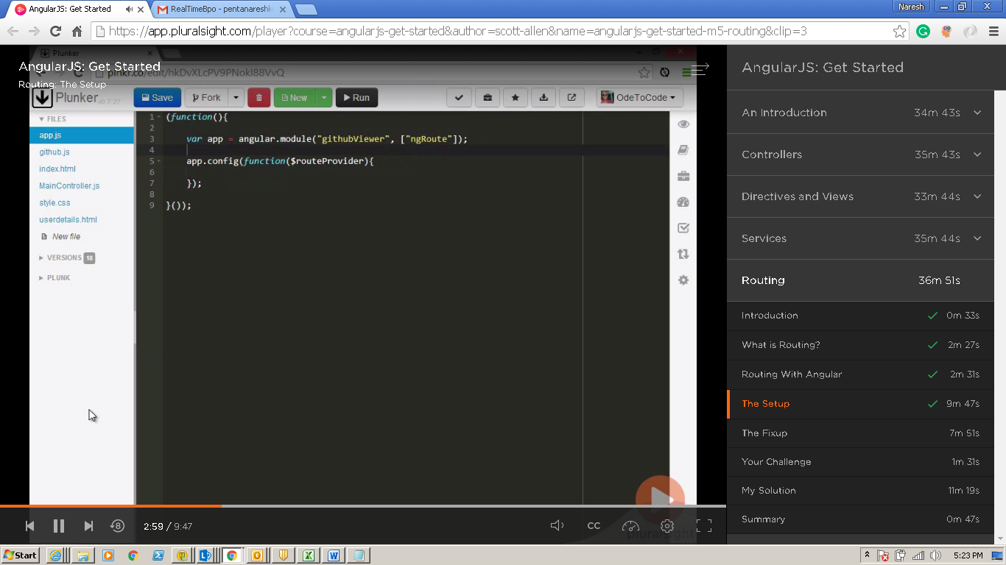

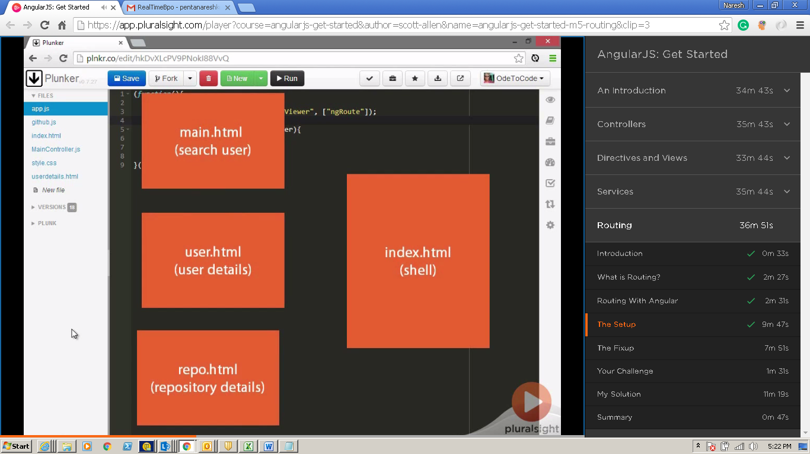

**Maincontroller.js**

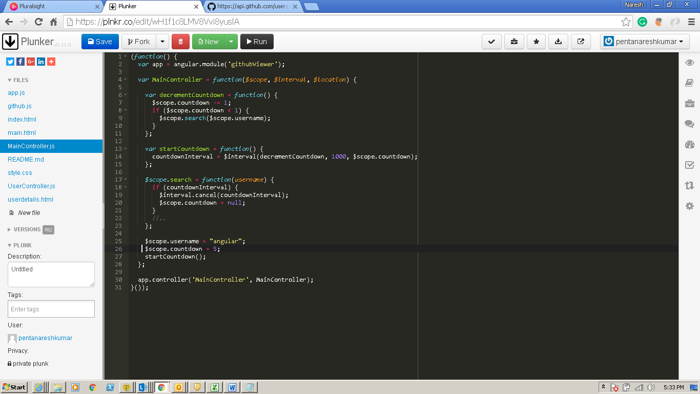

**Main.html**

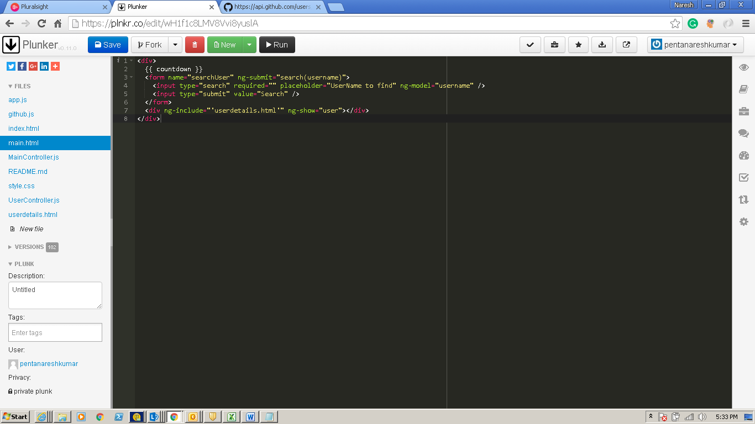

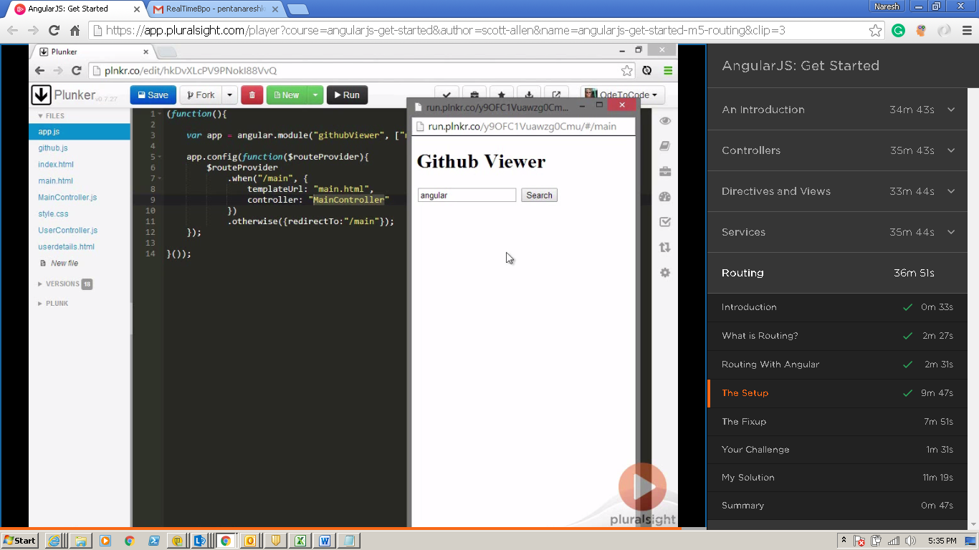

**User Router**

